A PROJECT REPORT ON

**“REMOTE HYPERVISOR”**

SUBMITTED BY

SOHIL GURUNG-16203A1004

AYUSH JAIN-16203A1013

DIPESH MISHRA-16203A1002

RHUSHIKESH DEULKAR-16203A1014

UNDER THE GUIDANCE OF

**PROF.VIJAY PATIL**

HEAD OF THE DEPARTMENT

**PROF.VIJAY PATIL**

DEPARTMENT OF COMPUTER ENGINEERING

VIDYALANKAR POLYTECHNIC

WADALA (E), MUMBAI 400037

MAHARASHTRA STATE BOARD OF TECHNICAL EDUCATION

2017-18



**Certificate**

This is to certify that the following students

SOHIL GURUNG

AYUSH JAIN

DIPESH MISHRA

RHUSHIKESH DEULKAR

Have completed the Project on

**“REMOTE HYPERVISOR”**

A partial fulfillment of the requirement of Third year Diploma in Computer Engineering affiliated to Maharashtra State Board of Technical Education, Mumbai for the Academic Year 2017-2018.

Internal Examiner External Examiner

Project Guide Head of Department Principal

ACKNOWLEDGEMENT

It is indeed a matter of great pleasure and proud privilege to be able to present this project on “**REMOTE HYPERVISOR**”.

We would like to express our special thanks of gratitude to our college principal **PROF. ASHISH UKIDVE** for providing us with this golden opportunity to work on this wonderful project.

The completion of the project work is a milestone in student life and its execution is in the hands. While doing research for this project we came across many new things that helped us widen our knowledge and expertise.

We are highly indebted to our project guide **PROF. VIJAY PATIL** for his invaluable guidance and appreciation for giving form and substance to this report. It is due to his enduring efforts, patience and enthusiasm which has given us a sense of direction and purposefulness to this project and ultimately made it a success.

We would like to tender our sincere thanks to the teaching and non-teaching staff members for their co-operation and assistance.

Secondly we would like to thanks friends who helped us a lot n finishing this project with all functionalities specified within the time limit.

Finally we would like to thank all those people who are indirectly connected with our project and lastly our colleagues.

[ SOHIL GURUNG ]

[ AYUSH JAIN ]

[ DIPESH MISHRA ]

[ RHUSHIKESH DEULKAR ]

**ABSTRACT**

ABSTRACT

In today's data center, virtualization is a standard practice. Creating and running a virtual machine in a physical desktop grade computers drastically leads to slow down its performance by approximately 50 percent and more than 50 percent in computers with old hardware and less amount of resources. But what if a piece of software lets you run a virtual machine in a desktop grade computers with ease and provide its peak performance to the user. This software would be immensely useful for us, in addition to a lot of other people. And that is our motivation for making this possible as my third year project.

**TABLE OF CONTENTS**

|  |  |  |
| --- | --- | --- |
| **CHAPTER NO** | **Topics** | **Page No** |
| **1**  **1.1**  **1.2**  **1.3**  **1.3.1**  **1.3.2** | **Introduction:**  **Basic terminologies.**  **What is Hypervisor.**  **Types of Hypervisor.**  **Type-1 hypervisor.**  **Type-2 hypervisor.** | **7**  **8**  **9**  **9**  **9**  **10** |
| **2**  **2.1**  **2.1.1**  **2.1.2**  **2.2**  **2.2.1**  **2.2.2**  **2.3**  **2.3.1**  **2.3.2** | **Review Of Literature:**  **Traditional Hypervisor Systems.**  **Image of Type-1 Hypervisor build.**  **Image of Type-2 Hypervisor build.**  **How traditional system works.**  **Working of Type-1 Hypervisor.**  **Working of Type-2 Hypervisor.**  **Problems with Traditional systems.**  **Problems with Type-1 Hypervisor.**  **Problems with Type-2 Hypervisor.** | **11**  **12**  **13**  **14**  **15**  **15**  **17**  **17**  **17**  **18** |
| **3**  **3.1**  **3.2**  **3.3** | **Plan Of Work:**  **Software Development Life Cycle.**  **Process Model.**  **Spiral Model.** | **19**  **20**  **22**  **23** |
| **4**  **4.1**  **4.1.1**  **4.1.2**  **4.2.1**  **4.2.1** | **Flow of the Project:**  **Flowchart.**  **Guidelines Of Flowchart.**  **Flowchart of the Project.**  **Algorithm.**  **Algorithm of our Project.** | **26**  **27**  **27**  **28**  **29**  **29** |
| **5**  **5.1**  **5.1.1**  **5.1.2**  **5.1.3**  **5.1.4**  **5.1.5**  **5.2.1** | **Analysis and Design:**  **Analysis Modelling.**  **Entity Relationship Diagram.**  **Elements of ER Diagram.**  **Basic concepts of ER Diagram.**  **Steps to create ER Diagram.**  **Basic ER Diagram of our Project.**  **Design Modeling.** | **30**  **31**  **31**  **32**  **32**  **32**  **33**  **34** |
| **6**  **6.1.1**  **6.1.2**  **6.1.3**  **6.2.1**  **6.3.1**  **6.4.1** | **Project Implementation:**  **Choosing The Platform.**  **Reasons We Used Linux.**  **Selecting the operating system.**  **Installation of Ubuntu OS.**  **Installation of several tools and utilities**  **Output of the Project.** | **35**  **36**  **37**  **38**  **39**  **45**  **64** |
| **7**  **7.1**  **7.2**  **7.3** | **Testing and Result:**  **Test Plan.**  **Test Activities.**  **Results.** | **77**  **78**  **79**  **82** |
| **8**  **8.1** | **Feasibility Analysis.**  **Feasibility Study.** | **85**  **86** |
| **9**  **9.1**  **9.2** | **Pros and Cons.**  **Advantages of our Project.**  **Disadvantages of our Project.** | **88**  **89**  **89** |
| **10**  **10.1** | **Applications.**  **Applications of our Project.** | **90**  **91** |
| **11**  **11.1** | **Future Development.**  **Future Development Of Our Project.** | **92**  **93** |
| **12**  **12.1**  **12.2** | **Conclusion and Bibliography.**  **Conclusion.**  **Bibliography / References.** | **94**  **95**  **95** |

**INTRODUCTION**

Chapter 1

INTRODUCTION:

1.1] BASIC TERMINOLOGIES:

* **Software**: Software is a general term for the various kinds of programs used to operate computer and related devices.
* **Hardware:** Hardware is the physical aspect of computers, telecommunications, and other devices.
* **Virtualization:** In computing, virtualization means to create a virtual version of a device or resource, such as a server, storage device, network or even an operating system where the framework divides the resource into one or more execution environments.
* **Operating System:** Operating system is an interface between the user and the computer hardware. Operating system may be based on Command Line Interface (CLI) or Graphical User Interface (GUI).
* **Host machine**: Host machine is the physical machine which is capable of running the guest (virtual) operating system or guest machine.
* **Guest Machine**: Guest machine is the machine which runs on a virtual environment with virtual hardware resources of the physical or host machine.
* **Virtual Machine**: A Virtual machine is an operating system which is ran with the help of supported applications.

1.2] WHAT IS HYPERVISOR?

A hypervisor or virtual machine monitor (VMM) is computer software firmware or hardware that creates and runs virtual machines. A computer on which a hypervisor runs one or more virtual machines is called host machine, and each virtual machine is called a guest machine. A hypervisor can run any type of operating systems (OS) such as (Microsoft windows, Apple MacOS, Linux, Unix, and so on) on a virtual environment with the help of virtual hardware resources.

1.3] TYPES OF HYPERVISOR:

A Hypervisor is classified into two types based on the structure in which it is implemented.

1.3.1] TYPE-1 HYPERVISOR:

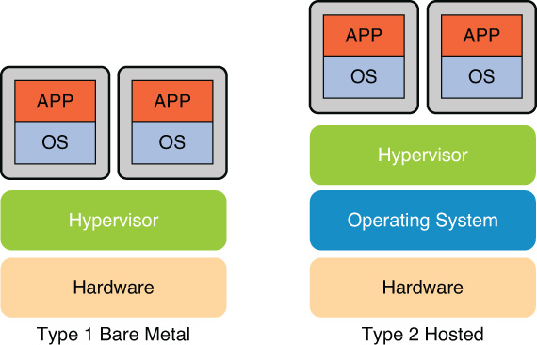

Type-1 Hypervisor runs directly on the host’s hardware to control the hardware and to manage guest (virtual) operating systems. For this reason, type-1 hypervisors are also called as bare metal hypervisor. Some of the bare metal hypervisor softwares are Oracle VM Server for SPARC, VMware ESX / ESXI, Microsoft Hyper-V and so on.

1.3.2] TYPE-2 HYPERVISOR



Type-2 Hypervisor runs on a conventional operating system (OS) just as other computer programs do. A guest (virtual) operating system runs as a process on the host machine. VMware workstation, VMware Player, Oracle Virtualbox and so on are the examples of Type-2 Hypervisor.

**REVIEW OF LITERATURE**

CHAPTER 2

REVIEW OF LITERATURE:

2.1] TRADITIONAL HYPERVISOR SYSTEMS:

In virtualization, the hypervisor (also called a virtual machine monitor) is the low-level program that allows multiple operating systems to run concurrently on a single host computer. Hypervisors use a thin layer of code in software or firmware to allocate resources in real-time. You can think of the hypervisor as the traffic cop that controls I/O and memory management.

Type-1 hypervisor runs directly on the system hardware. They are often referred to as a "native" or "bare metal" or "embedded" hypervisors in vendor literature.

Type 1 hypervisors are gaining popularity because building the hypervisor into the firmware is proving to be more efficient. According to IBM, Type 1 hypervisors provide higher performance, availability, and security than Type 2 hypervisors. (IBM recommends that Type 2 hypervisors be used mainly on client systems where efficiency is less critical or on systems where support for a broad range of I/O devices is important and can be provided by the host operating system.)

A Type 1 hypervisor provides better performance and greater flexibility because it operates as a thin layer designed to expose hardware resources to virtual machines (VMs), reducing the overhead required to run the hypervisor itself.

Because a Type 1 hypervisor runs directly on the hardware, it is a function in and of itself. Servers that run Type 1 hypervisors are often single-purpose servers that offer no other function. They become part of the resource pool and are designed specifically to support the operation of multiple applications within various Virtual Machines (VMs).

Experts predict that shipping hypervisors on bare metal will impact how organizations purchase servers in the future. Instead of selecting an OS, they will simply have to order a server with an embedded hypervisor and run whatever OS they want.

2.1.1] Below is the image of Type-1 VMWare ESXI 5.0.0 Hypervisor build:

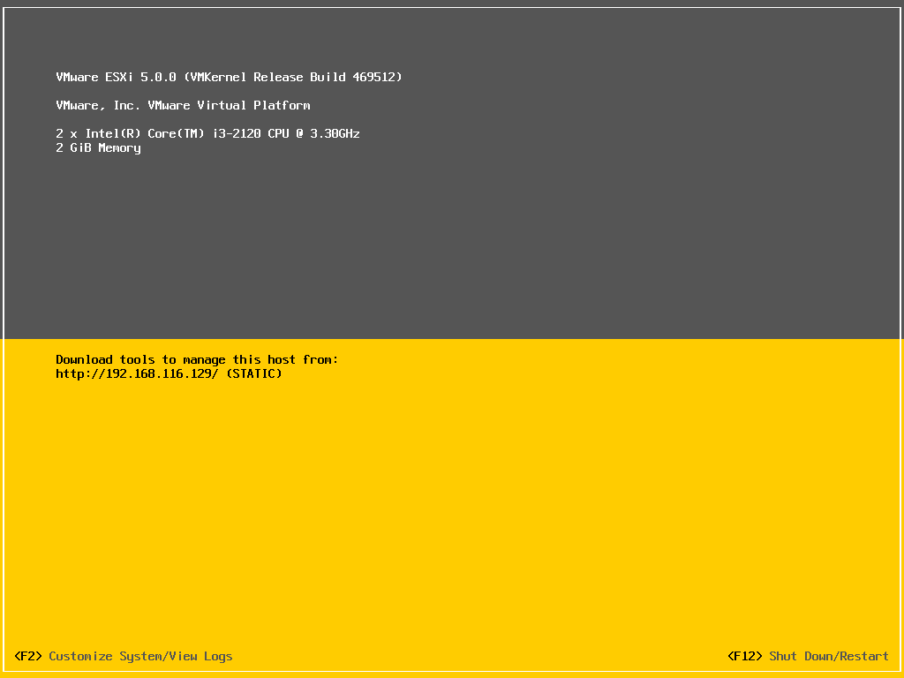

Type 2 hypervisors run on a host operating system as an application. When the virtualization movement first began to take off, Type 2 hypervisors were most popular Administrators could buy the software and install it on a server they already had.

Type 2 hypervisors support guest virtual machines by coordinating calls for CPU, memory, disk, network and other resources through the physical host's operating system. This makes it easy for an end user to run a virtual machine on a personal computing device. Examples of this type of hypervisor include VMware Fusion, Oracle Virtual Box, Oracle VM for x86, Solaris Zones, Parallels and VMware Workstation.

2.1.2] Below is the image of Type-2 VMWare Workstation 11 Hypervisor build:

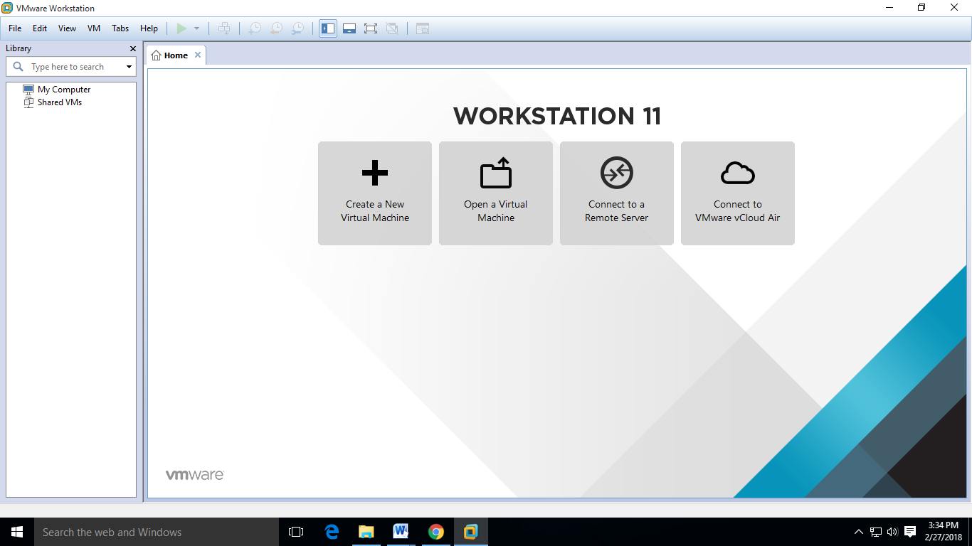

2.2] HOW TRADITIONAL HYPERVISOR SYSTEM WORKS:

2.2.1] TYPE-1 HYPERVISOR:

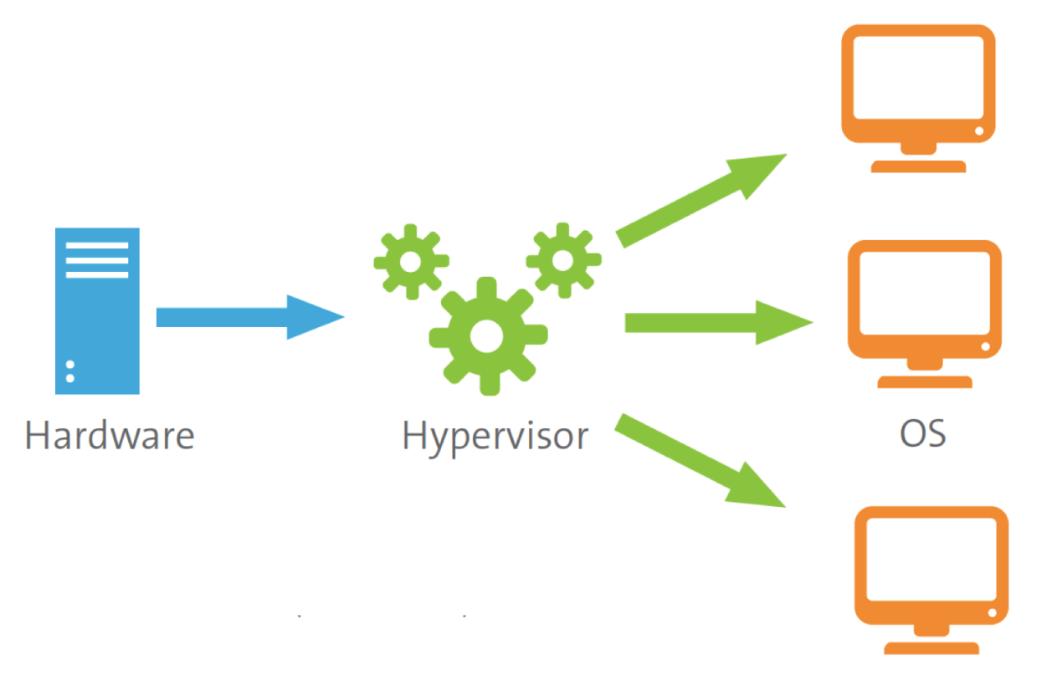

* The Type-1 Hypervisor software such as “Xen Server”, “VMWare ESXI” and so on is first installed on a Hardware device.
* A compatible Client application such as “VSphere Client” is installed on the client machine for managing the host machine.
* On the host machine, guest (virtual) machine is created by allocating virtual hardware resources and devices to the guest machine with the help of client application such as “VSphere Client” for ”VMWare ESXI”.
* Once the guest system is created, an operating system is installed on the guest machine.
* After the Operating system gets installed on the guest machine, the guest machine becomes ready to use for end user or the system and network administrators.
* For all of the above functionality, a client machine and the respective client application such as “VSphere Client” for “VMWare ESXI” is required.

2.2.2] TYPE-2 HYPERVISOR:

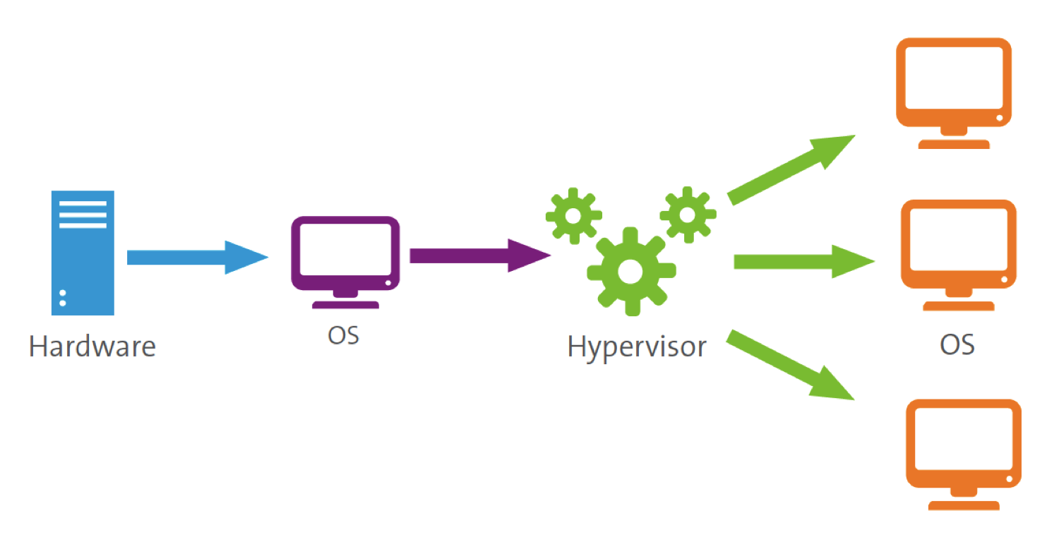

* Unlike Type-1 Hypervisor, a desktop grade operating system such as “Microsoft Windows”, “Ubuntu Desktop Linux”, etc is first installed on the computer hardware.
* The type-2 hypervisor software such as “VMWare Workstation”, “Oracle VirtualBox”, etc is then installed on the Operating system.
* On the host machine, the guest machine is created by allocating virtual hardware resources and devices with the help of the type-2 hypervisor software.
* After creating the guest machine, an operating system is installed on the guest machine.
* Once the operating system gets installed on the guest machine, the guest machines becomes ready to use for end user or system administrator.

2.3] PROBLEMS WITH TRADITIONAL HYPERVISOR SYSTEMS:

2.3.1] TYPE-1 HYPERVISORS:

* No other operations can be performed accept running the guest (virtual) Operating Systems (OS).
* Separate Desktop grade Machine is required to manage the Type-1 Hypervisor host machine.
* Additional Client Application is required to manage the Host machine.
* Only Minimal configurations such as IP Address of the host machine can be changed.
* Doesn’t provide functionality of an operating system.
* Doesn’t work as a standalone system.
* Provides a minimalistic User Interface (UI).
* If the host machine fails, then the entire virtual environment tends to fail.
* No additional services and can be implemented on the host machine.
* No additional application programs can be implemented on the host machine.
* No security features are available, hence compromises in security.
* Cannot be used as a Desktop grade machine.
* Virtual Machines cannot be accessed remotely.

2.3.2] TYPE-2 HYPERVISOR:

* Needs more hardware resources than compared to type-1 hypervisor.
* A desktop operating system is required.
* Comparatively slower than type-1 hypervisor.
* Additional type-2 hypervisor software is required.
* Virtual Machines of one host machines are not accessible on different host machines.
* Cannot be implemented on an operating system with Command Line Interface (CLI).
* If the operating system of the host machine gets corrupted, then entire virtual environment gets destroyed.
* Virtual Machines cannot be accessed remotely.
* Type 2 Hypervisor softwares are not based on open-source platform.
* Some of the type-2 hypervisor applications are comparatively expensive.

**PLAN OF WORK**

CHAPTER 3

PLAN OF WORK:

3.1] SOFTWARE DEVELOPMENT LIFE CYCLE:

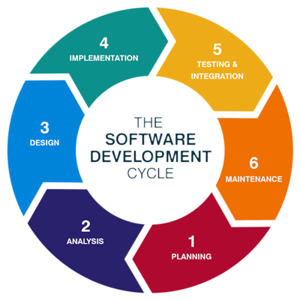

* Planning

Planning is an objective of each and every activity, where we want to discover things that belong to the project. An important task in creating a software program is extracting the requirements or requirements analysis. Customers typically have an abstract idea of what they want as an end result, but not what software should do. Skilled and experienced software engineers recognize incomplete, ambiguous, or even contradictory requirements at this point. Frequently demonstrating live code may help reduce the risk that the requirements are incorrect. Once the general requirements are gathered from the client, an analysis of the scope of the development should be determined and clearly stated. This is often called a scope document. Certain functionality may be out of scope of the project as a function of cost or as a result of unclear requirements at the start of development.

* Implementation, Testing and Documenting

Implementation is part of the process where software engineers actually program the code for the project. Software testing is an integral and important phase of the software development process. This part of the process ensures that defects are recognized as soon as possible documenting the internal design of software for the purpose of future maintenance and enhancement is done throughout development. This may also include the writing of an API, be it external or internal. The software engineering process chosen by the developing team will determine how much internal documentation (if any) is necessary

* Deployment and maintenance

Deployment starts after the code is appropriately tested, approved for release, and sold or otherwise distributed into a production environment. This may involve installation, customization, testing and possibly an extended period of evaluation. Software training and support is important, as software is only effective if it is used correctly

Maintaining and enhancing software cope with newly discovered requirements can take substantial time and effort, as missed requirements may force redesign of the software.

3.2] PROCESS MODEL:

There are different types of models used by a software team to do their work systematic that is step by step. The original process models have certainly given a guideline or roadmap for the whole software development process or software engineering

The process models are properly structured so that at least structure so that process can be understood. The different process models are:

* Waterfall Model
* Incremental Model
* RAD Model
* Prototype Model
* Spiral Model

We have chosen the SPIRAL MODEL for the development for our project .

3.3] SPIRAL MODEL:

The spiral model is similar to the [incremental model](http://istqbexamcertification.com/what-is-incremental-model-advantages-disadvantages-and-when-to-use-it/), with more emphasis placed on risk analysis. The spiral model has four phases: Planning, Risk Analysis, Engineering and Evaluation. A software project repeatedly passes through these phases in iterations (called Spirals in this model). The baseline spirals, starting in the planning phase, requirements are gathered and risk is assessed. Each subsequent spiral builds on the baseline spiral. It’s one of the [software development models](http://istqbexamcertification.com/what-are-the-software-development-models/) like [Waterfall](http://istqbexamcertification.com/what-is-waterfall-model-advantages-disadvantages-and-when-to-use-it/), [Agile](http://istqbexamcertification.com/what-is-agile-model-advantages-disadvantages-and-when-to-use-it/), [V-Model](http://istqbexamcertification.com/what-is-v-model-advantages-disadvantages-and-when-to-use-it/).

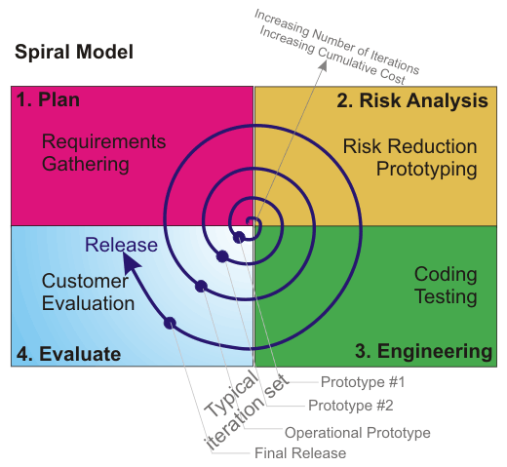

* **Planning Phase:**

Requirements are gathered during the planning phase. Requirements like ‘BRS’ that is ‘Business Requirement Specifications’ and ‘SRS’ that is ‘System Requirement specifications’.

* **Risk Analysis:**

  In the**risk analysis phase**, a process is undertaken to identify risk and alternate solutions.  A prototype is produced at the end of the risk analysis phase. If any risk is found during the risk analysis then alternate solutions are suggested and implemented.

* Engineering Phase:

In this phase software is**developed**, along with [testing](http://istqbexamcertification.com/what-is-a-software-testing/) at the end of the phase. Hence in this phase the development and testing is done.

* E**valuation phase:**

This phase allows the customer to evaluate the output of the project to date before the project continues to the next spiral.

ADVANTAGES OF SPIRAL MODEL:

* High amount of risk analysis hence, avoidance of Risk is enhanced.
* Good for large and mission-critical projects.
* Strong approval and documentation control.
* Additional Functionality can be added at a later date.
* Software is produced early in the [software life cycle](http://istqbexamcertification.com/what-are-the-software-development-life-cycle-phases/).

**FLOWCHART AND ALGORITHM**

CHAPTER 4

FLOW OF THE PROJECT:

4.1] FLOWCHART:

A flowchart is a type of diagram that represents an algorithm, workflow or process, showing the steps as boxes of various kinds, and their order by connecting them with arrows. This diagrammatic representation illustrates a solution model to a given problem A flowchart is described as "cross-functional" when the page is divided into different swim lanes describing the control of different organizational units. A symbol appearing in a particular "lane" is within the control of that organizational unit. This technique allows the author to locate the responsibility for performing an action or making a decision correctly, showing the responsibility of each organizational unit for different parts of a single process. Flowcharts are used in analyzing, designing, documenting or managing a p rocess or program in various fields.

The flowchart of our project is describing the general flow of data that how the user will log in and can create and access the virtual machines remotely.

We have tried our best to create our flow chart as simple as possible so that the flow of data of our system becomes easy for us to understand.

4.1.1] GUIDELINES OF FLOWCHART:

* In drawing a proper flow chart, all necessary requirements should be listed out in logical order.
* The flowchart should be clear, neat and easy to follow.
* The usual direction of the flow of a procedure or system is from left to right or top to bottom.
* Only one flow line should come out from a process symbol.
* Only one flow line should enter a decision symbol, but two or three flow lines, one for each possible answer, should leave the decision symbol.
* Only one flow line is used in conjunction with terminal symbol.

**4.1.2] BELOW IS THE FLOW CHART OF OUR PROJECT:**

NO

YES

EXISTING VM IS PRESENT?

SIGN IN

END

SUSPEND / SHUTDOWN VIRTUAL MACHINE

START VIRTUAL MACHINE

CREATE VIRTUAL MACHINE

REGISTER

START

4.2.1] ALGORITHM:

* An algorithm is a procedure or formula for solving a problem, based on conducting a sequence of specified actions.
* A computer program can be viewed as an elaborate algorithm.
* In computer science, an algorithm usually means a small procedure that solves a recurrent problem.
* Algorithms are widely used throughout all areas of Information Technology,
* A search engine algorithm for example, takes search strings of keywords and operators as input, searches its associated database for relevant web pages, and returns results.

We have tried to create as simple algorithm as possible of our system so that it is becomes easy for us to understand the working of our system.

4.2.2] ALGORITHM OF OUR PROJECT:

STEP 1: Create a user ID and password of the user who is going to create and access the virtual machine.

STEP 2: Log in to the web portal with the given user ID and Password.

STEP 3: Create a virtual machine with required virtual resources. If Existing virtual machine is present, than jump to STEP 4.

STEP 4: Start and access the virtual machine which is created on the STEP 3

STEP 5: Shutdown or suspend the virtual machine once the work is done.

STEP 6: Log out from the web portal.

**ANALYSIS AND DESIGN**

CHAPTER 5

5.1] ANALYSIS MODELLING:

* Analysis model make use of test and diagrammatic forms in a combination to represent requirements of data, function and behavior for easy understanding of overall requirements of the system.
* Analysis model validate the software requirements and represent the requirements in multiple dimensions.
* Basic aim of analysis modeling is to create the model that represents the information, functions, behavior of the system to be built.
* The analysis model is set or collection of models and is first technical representation of a system.
* Analysis model can be represented by several diagrammatic representations such as Entity Relationship (ER) Diagram, Data Flow Diagram (DFD and State Transition Diagram (STD).

5.1.1] ENTITY RELATIONSHIP DIAGRAM:

* Entity Relationship diagram is mainly used to represent the relationship between two entities or data object.
* The ER diagram is the notation that is used to conduct the data.
* This diagram is used to execute data modelling activity.

5.1.2] ELEMENTS OF ENTITY RELATIONSHIP DIAGRAM:

* **Entities** are the things for which we want to store information. An entity is person, place, thing or event.

ENTITY

* **Attributes** are the data we want to collect for an entity.
* **Relationships** describe the relations between the entities.

RELATIONSHIP

5.1.3] BASIC CONCEPTS OF ENTITY RELATIONSHIP DIAGRAM:

* **RELATIONSHIP** indicates how data objects are related to one another.
* **CARDINALITY** represents number of occurrences of another object.
* **MODALITY** of relationship is zero if occurrence of relationship is optional and modality of relationship is 1 if occurrence of relationship is mandatory. Thus the modality specifies the minimum number of relationship.

5.1.4] STEPS INVOLVED IN CREATING AN ENTITY RELATIONSHIP DIAGRAM INCLUDE:

* Identifying and defining the entities.
* Determining all interactions between the entities.
* Analyzing the nature of interactions / determining the cardinality of the relationships.
* Creating the Entity relationship Diagram.

5.1.5] Below is the basic Entity Relationship diagram of our system:

LOGS

IN

USER

VIRTUAL

MACHINE

* Entity Relationship Diagram for Accessing the virtual machines.

5.2] DESIGNING:

5.2.1] DESIGN MODELLING:

* Software design plays an important role in software development process.
* Design is very basis of further development of product.
* Good design ensures sustainable software product which is highly reliable and standard.
* Design modeling takes help of different diagrams and creates complete picture of the software before we actually develop it.
* Software design is an iterative process that is used to translate requirements into the design model or blueprint of the construction of the software.
* Three characteristics that serve as a guide for the evaluation of a good design are:
  + The design must implement all of the explicit requirements contained in the analysis model.
  + The design must be readable.
  + The design need to give complete idea or picture of software, addressing the data, functional, and behavioral domains.
* Following is a set of fundamental software design concepts:

Modularity

Patterns

Architecture

Abstraction

Refactoring

Refinement

Information Hiding

**PROJECT IMPLEMENTATION**

CHAPTER 6

6.1.1] CHOOSING THE PLATFORM:

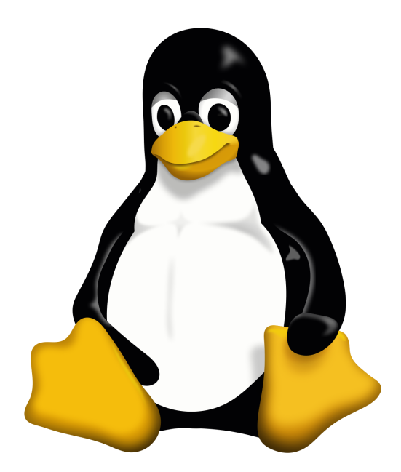

* **LINUX**

For operating system, we have decided to go with Linux.

* Linux is a family of free and open source software operating systems built around the linux kernel.
* Typically, Linux is packaged in a form known as a Linux distribution for both desktop and server use. The defining component of a Linux distribution is the Linux Kernel, an operating system Kernel first released on September 17, 1991, by Linus Torvaids.
* Many Linux distributions use the word Linux in their name.
* Linux was originally Developed for personal computers based on the Intel x86 architecture, but has since been ported to more platforms than any other operating system.
* Because of Dominance of the linux kernel based Android OS on smartphones, Linux has largest installed base of all general-purpose operating system.

6.1.2] REASONS WE USED LINUX:

* Linux is **Portable** hence it can work on different types of hardware in same way.
* Linux is **Open-Source** and hence the source code is freely available and it is community based development project.
* Linux is **Multi-user** operating system which means multiple users can access system resources like memory / ram / application program at same time.
* Linux is **Multiprogramming** system means multiple applications can run at same time.
* Linux provides a standard **Hierarchical File System** in which files are decently arranged.
* Linux provides a special interpreter program called as **Shell** which can be used to execute commands of the operating system.
* Linux provides user **Security** using authentication features like password protection / controlled assess to specific files / encryption of data.
* Almost all Linux Distributions have **Live CD / USB** feature by which user can run / try the OS even without installing it on the system.
* Since Linux is an open-source operating system, it is completely **FREE** to install and use.
* There is not many malwares that are aimed at compromising a Linux system and so you statistically don’t need an anti-virus.

These were some of the Key features of Linux due to which we decided to go with Linux.

6.1.3] SELECTING THE OPERATING SYSTEM:

* UBUNTU DESKTOP 14.04 LTS:



* Ubuntu is an open source operating system for computers.
* It is a Linux distribution based on the Debian architecture.
* It is usually run on personal computers, and is also popular network servers, usually running the Ubuntu Server variant, with enterprise class features.
* Ubuntu runs on the most popular architectures, including Intel, AMD, and ARM based machines. Ubuntu is also available for tablets and smartphones, with the Ubuntu Touch edition.
* Ubuntu is the most popular operating system running in hosted environments, so called clouds, as it is the most popular server Linux Distribution.
* Some of the Ubuntu Builds which were released are:

* + Ubuntu 14.04 LTS (Codenamed “Trusty Tahr”).
  + Ubuntu 15.04 (Codenamed “Vivid Vervet”).
  + Ubuntu 16.04 LTS (Codenamed “Xenial Xerus”).
  + Ubuntu 17.04 (Codenamed “Zesty Zapus”).
  + Ubuntu 18.04 LTS (Codenamed “Bionic Beaver”).

6.2.1] INSTALLATION OF UBUNTU DESKTOP 14.04 OPERATING SYSTEM:

1] CLICK INSTALL:

Once you have booted with LIVE CD / USB, you will be presented with a screen that looks like this.

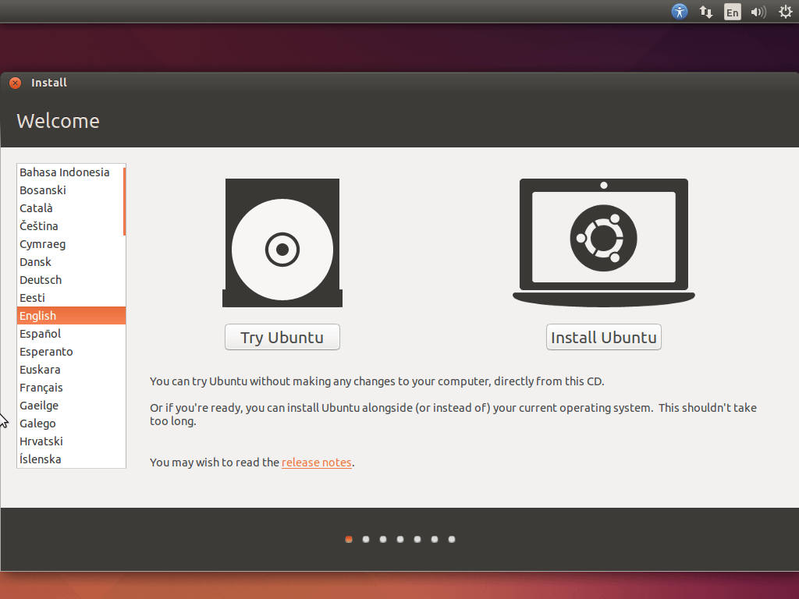

* Click on **Install Ubuntu** to install the operating system.
* You can open the installer again later if you choose to try it out by Clicking on **Try Ubuntu**, but remember it will be far slower running from a Disc/USB than had you installed it, and nothing you do will actually be saved.

2] CHECK BOTH BOXES:

Once you have clicked on install Ubuntu, you will be presented with the screen that looks like this.

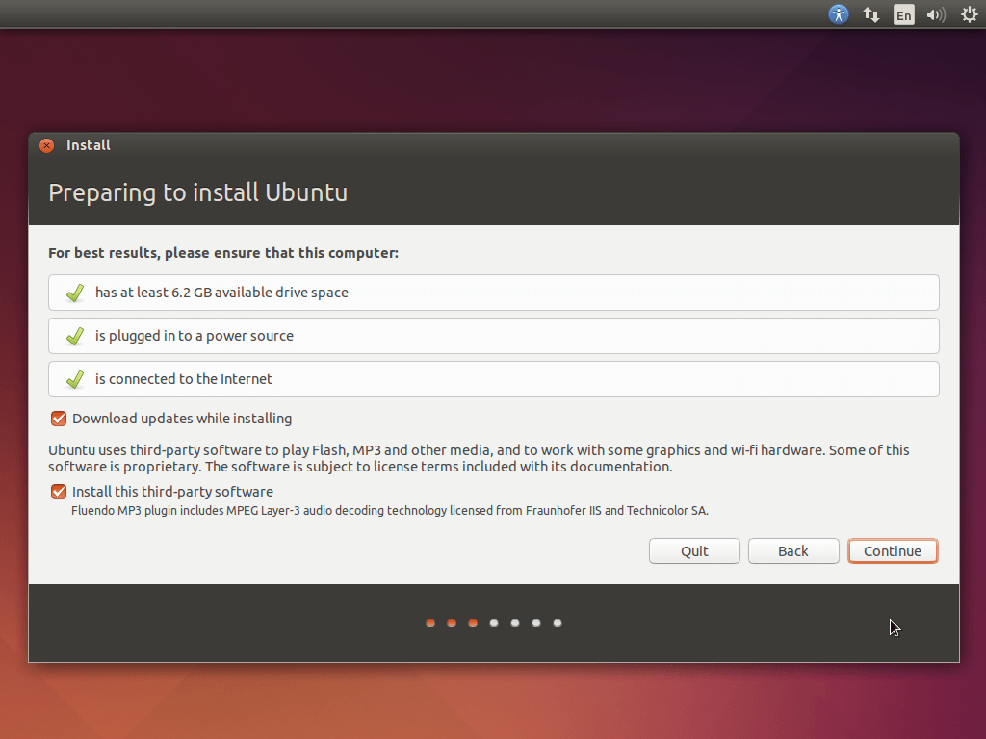

* We recommend checking both boxes, but if you don't want to install all updates while installing, or don't want to play MP3 files (music), then you can leave the relevant box(es) unchecked.
* At this point there must be at least 6.2 GB of available drive space or else, installation will get failed.
* If you're not plugged in, then plug in before continuing.
* If you're not connected to the internet, then you'll be prompted to connect when you click continue.

3] CHOOSE HOW TO INSTALL:

At this point, you will be presented with the screen like this.

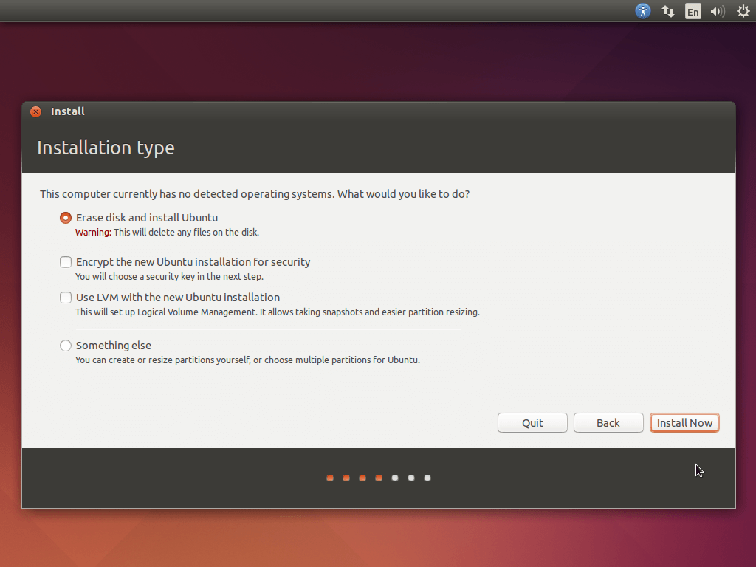

* Yours will probably look a little different to mine here.
* My hard drive doesn't have anything on it yet, so i can choose either to use the whole disk, or specify partitions manually.
* It may say Delete Windows, Install Ubuntu and Shrink Windows and Install Ubuntu Alongside.
* Choosing to install alongside will mean you are presented with a menu with the option to choose which operating system with the arrow keys and enter every time you turn on your computer.
* For simplicity, click on Erase disk and install Ubuntu. ( NOTE: Please take the backup of your computer before doing this step. )

4] CHOOSE YOUR LOCATION:

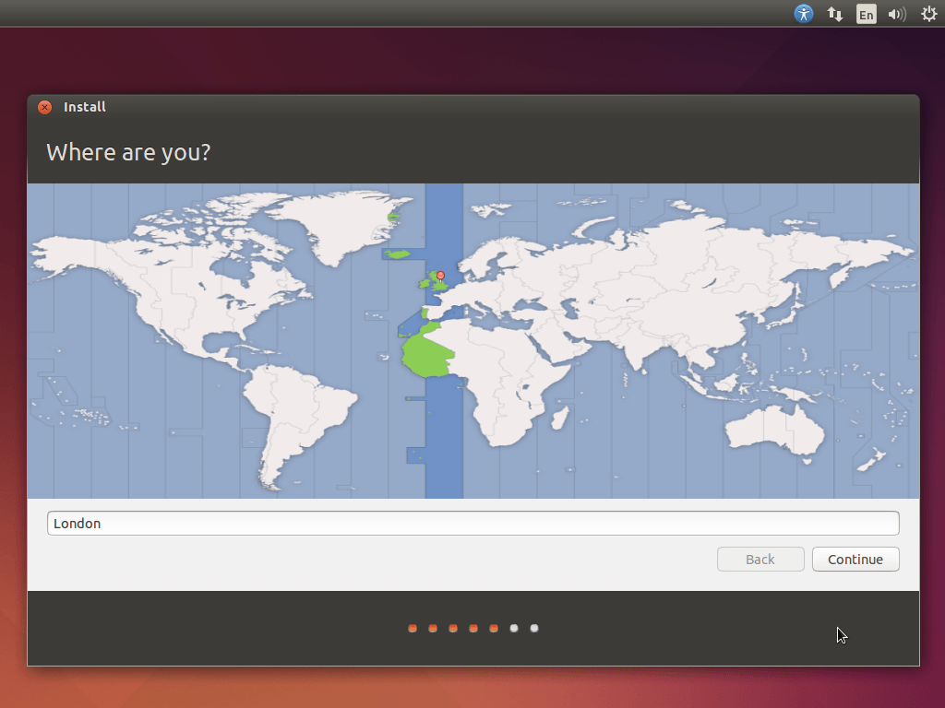

* Now you get to choose your location by dropping a pin on this nifty looking map. This is to select your timezone and apply any regional adjustments.
* Since we are from India, We have dropped the pin on the India.
* By selecting a location on the map, Ubuntu gets configured with the native regional language in which you have pinned.

5] CHOOSE THE KEYBOARD LAYOUT:

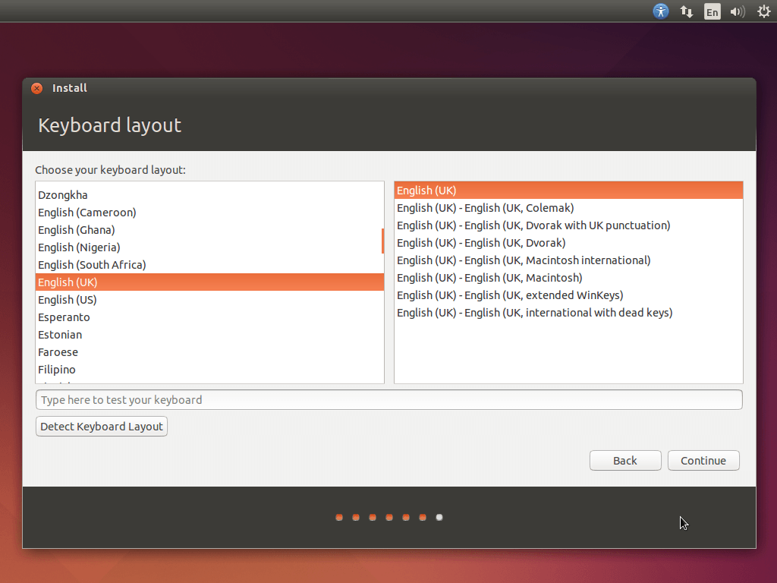

* This is probably the most technical step in the installation, made a lot simpler by the Detect Keyboard Layout. Just click that and follow the instructions on screen.
* For simplicity, choose the English (US) on the screen.

6] SET USER NAME AND PASSWORD:

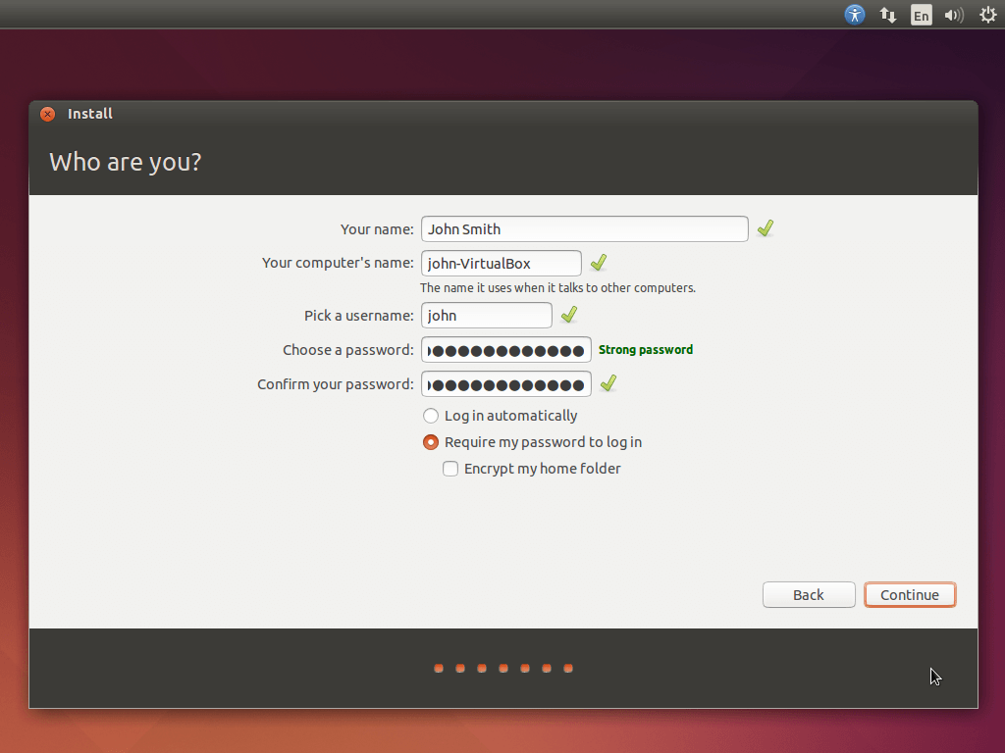

* Now you get to enter your name, the name you want your computer to be, your username, a password, whether or not to log in automatically, and whether or not to encrypt your home folder.
* I would not recommend encrypting your home folder, as this usually complicates things for you as much as any potential trespassers.
* Then click on “Continue” and sit back and relax until the installation of Ubuntu gets finished automatically.
* Once the installation is done, click on “Restart” button to restart on to the operating system.

6.3.1] INSTALLATION OF SEVERAL TOOLS AND UTILITIES:

OPENING THE TERMINAL:

* Once the installation of the operating system is done, open terminal window by pressing CTRL + ALT + T at the same time.

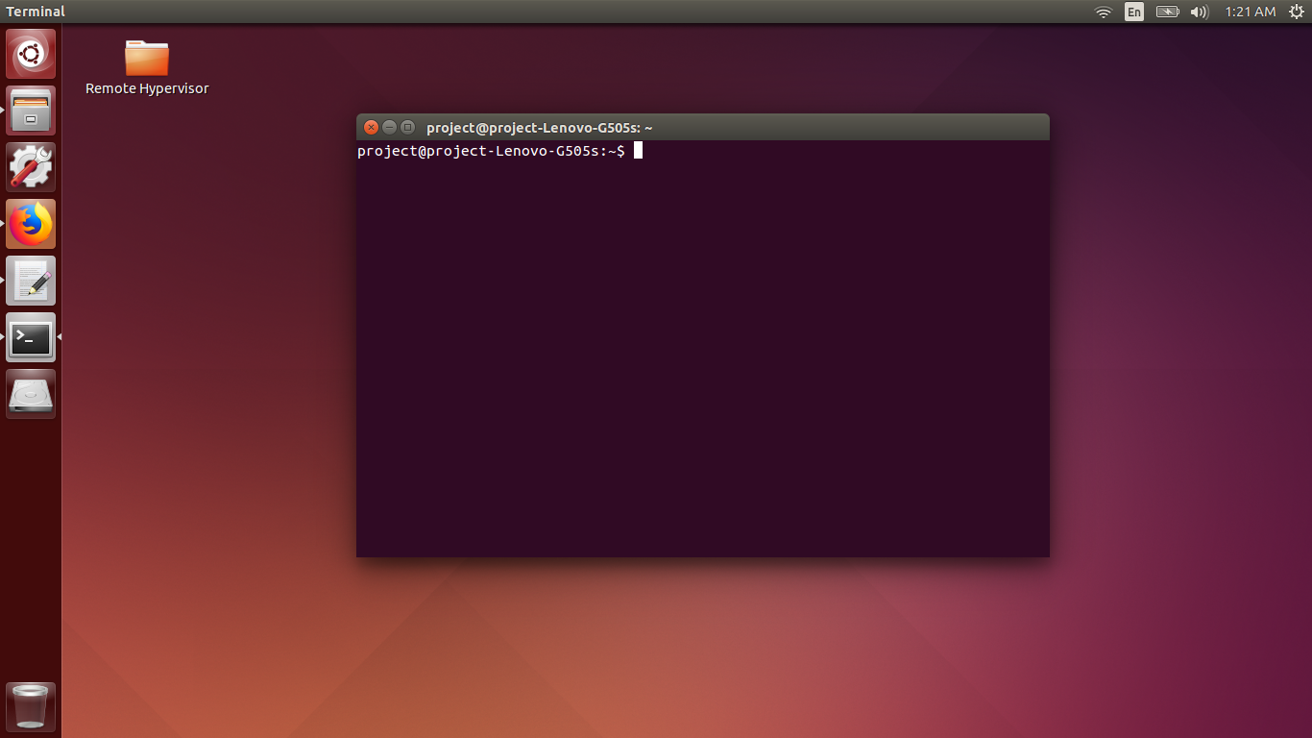

* Terminal window in Ubuntu is an application which lets you run several commands.
* This window is similar to Command Prompt in windows operating system.
* Even though it is similar, all the commands of terminal window and command prompt are different.
* In Linux, terminal windows plays a very important role as it executes and interprets the commands.
* All distributions with different builds will have some exclusive commands which will be able to run on that particular build only.

UPDATING THE PACKAGES:

* Once the terminal window is opened, type the following command “**sudo apt-get update**” and enter the password which was set during the installation process at step 6.

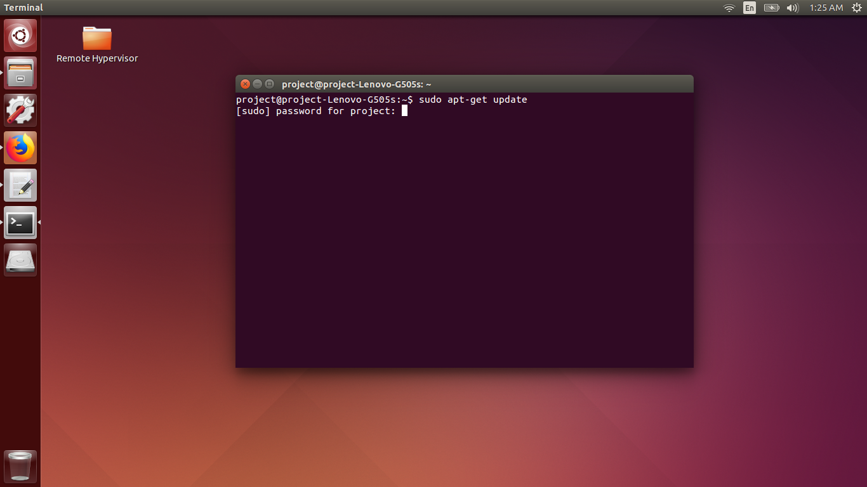

* “**sudo apt-get update**” doesn’t actually install new version of software, instead it updates the package lists for upgrades for packages that need upgrading as well as new packages that have just come to the repositories.
* With the help of this command, the outdated packages gets updated with the current versions or builds of the packages.
* **sudo** ("superuser do", or "switch user do") allows a user with proper [permissions](https://www.computerhope.com/jargon/p/permissi.htm) to execute a command as another user, such as the [superuser](https://www.computerhope.com/jargon/r/root.htm).
* **apt-get** is the [command-line](https://www.computerhope.com/jargon/c/commandi.htm) tool for working with APT software [packages](https://www.computerhope.com/jargon/p/package.htm). APT (the Advanced Packaging Tool) is an evolution of the Debian .deb software packaging system. It is a rapid, practical, and efficient way to install packages on your system.

CHANGING THE DIRECTORY TO HOME DIRECTORY:

* After all the packages get updated, insert the next command “**cd /home/project**”.

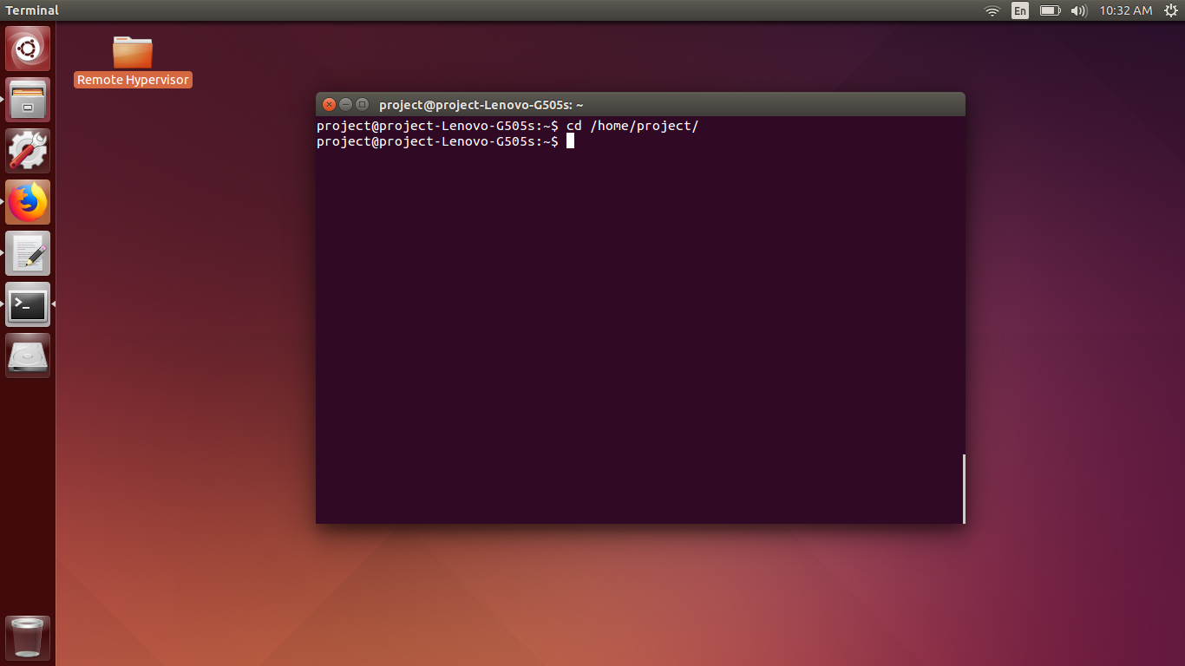

* “**cd**” command stands for “Change Directory”. This command is used to change position form current directory to the specified directory.
* “**/home/project**”:
  + /home is a common directory for all the users.
  + Home directory holds the data of all the users in the system.
  + /project is the directory of the user with the username “project”.

VALIDATING ALL THE CONFIGURATIONS REQUIRED BY THE SYSTEM:

* After changing the directory to the users directory, run the command “**lscpu**” to check the necessary configurations.

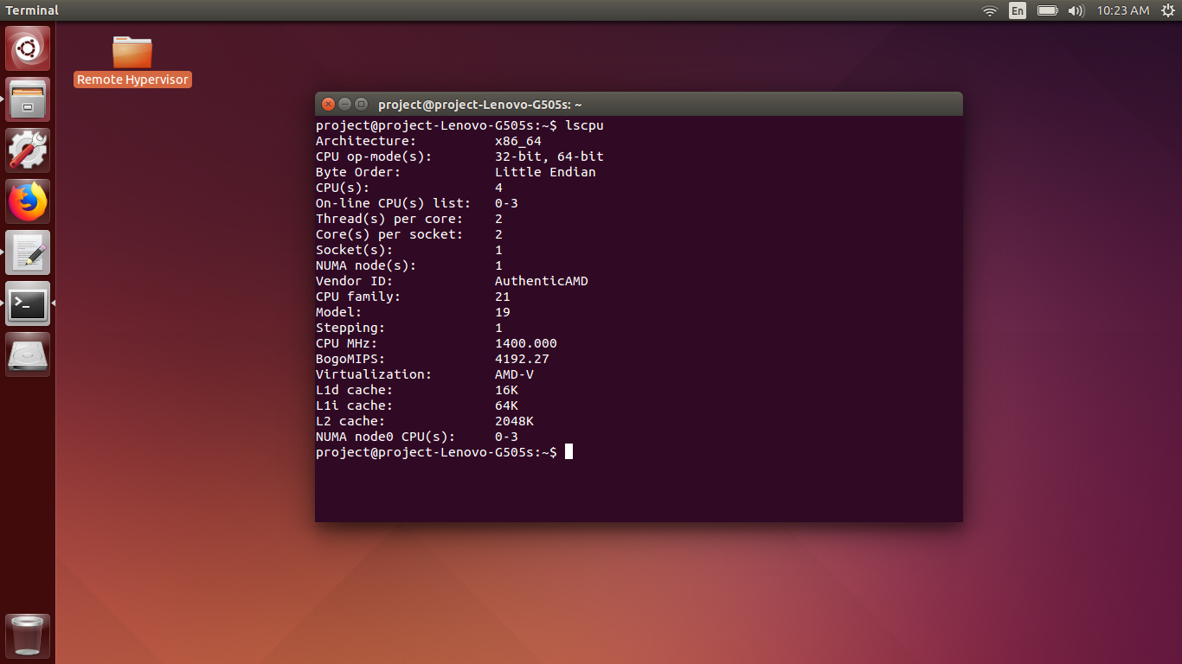

* The “**lscpu**” command shows the cpu configurations of the system.
* In the output window, check for the virtualization option.
* If the output window shows virtualization as AMD-V or Intel VTX, then the system supports virtualization.
* If the AMD-V or Intel VTX is present, then we are good to go for further installations and configurations.

INSTALLATION OF KVM AND LIBVIRT:

* In this step, run the following command “**sudo apt-get install qemu-kvm libvirt-bin**”.

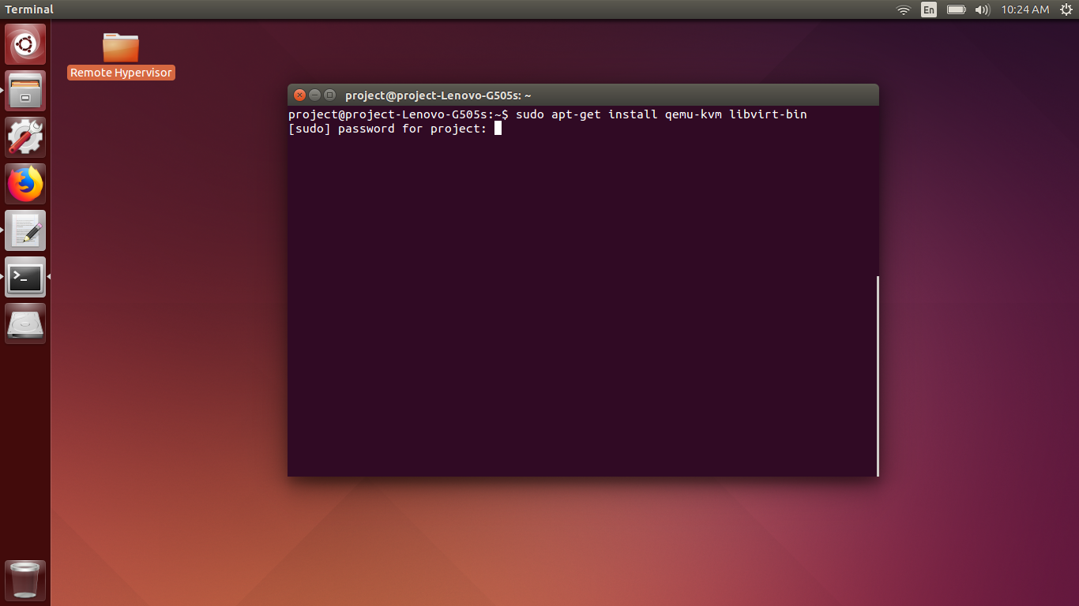

* “**qemu-kvm**”: QEMU (short for Quick Emulator) is a free and open source hosted hypervisor that performs hardware virtualization.
* QEMU is a hosted virtual machine monitor: It emulates CPUs through dynamic binary translation and provides a set of device models. Enabling it to run a variety of unmodified guest operating systems.
* It also can be used with KVM to run virtual machines at near-native speed.
* “**libvirt-bin**” : The Libvirt library is used to interface with different virtualization technologies.

ADDING USER TO KVM GROUP:

* After the qemu-kvm and libvirt-bin is installed, execute the following command “**sudo adduser project kvm**” and type the password of user which is set during the installation.

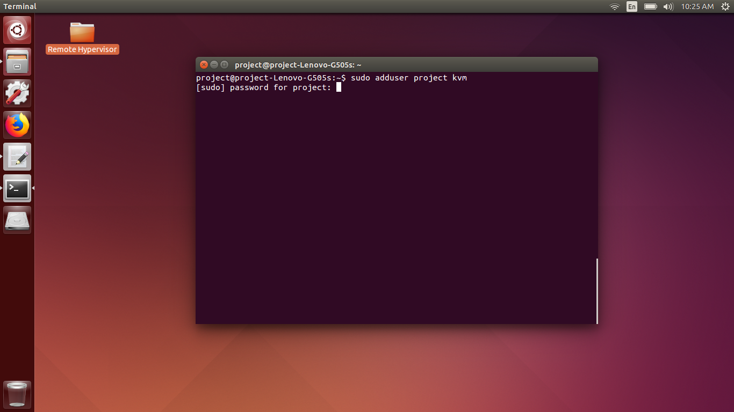

* In the above command, “**adduser**” command is used to add the following user into the group which is mentioned above.
* “**project**” is the username of the user which is going to be added on the group “kvm”.
* “**kvm**” is the group in which the user is going to be added.

VIEWING THE LIST OF VIRTUAL OR GUEST MACHINES:

* Once the user is added into the kvm group, run the following command “**virsh list –all**”.

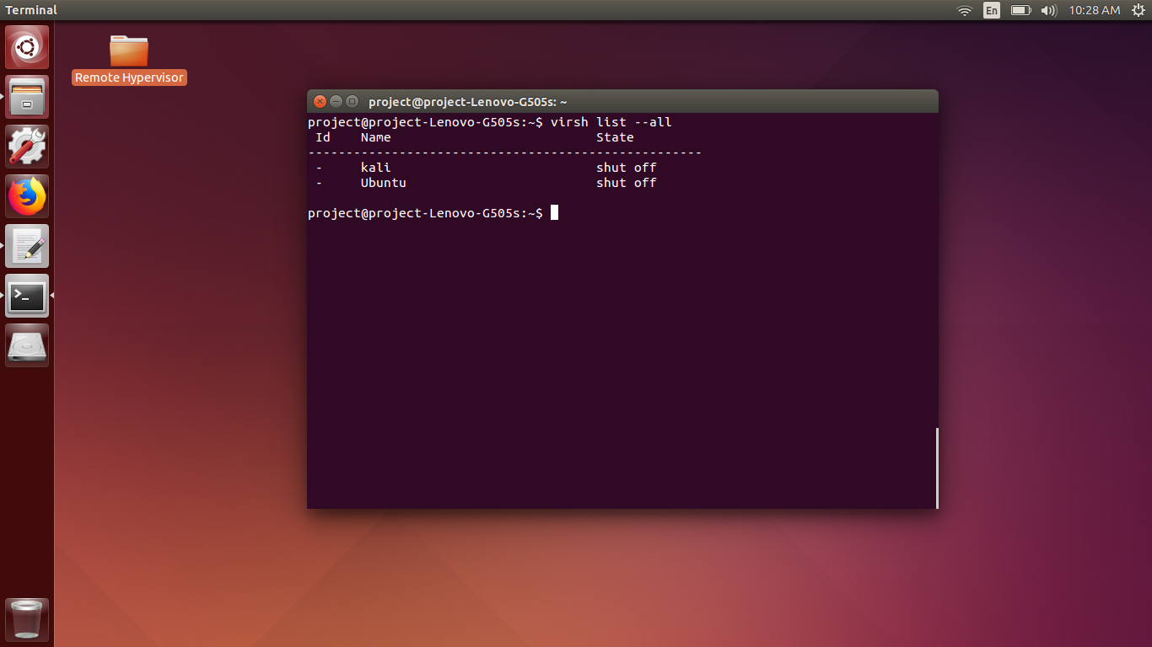

* In the above command, “**virsh**” stands for “virtual show” which is used to show the available virtual or guest machines.
* “**virsh**” is also used to view the status of the virtual machines.
* “**list**” in the following command is used to list the guest machines.
* “**- -all**” is used to view all the guest machines. We can also specify the name of the virtual machine instead of “- -all” to view the status of the specified guest machine.

INSTALLATION OF THE REMAINING UTILTIES:

* To install the remaining utilities execute the following command
  + **“sudo apt-get install git python-pip python-libvirt python-libxml2 novnc supervisor nginx.”**

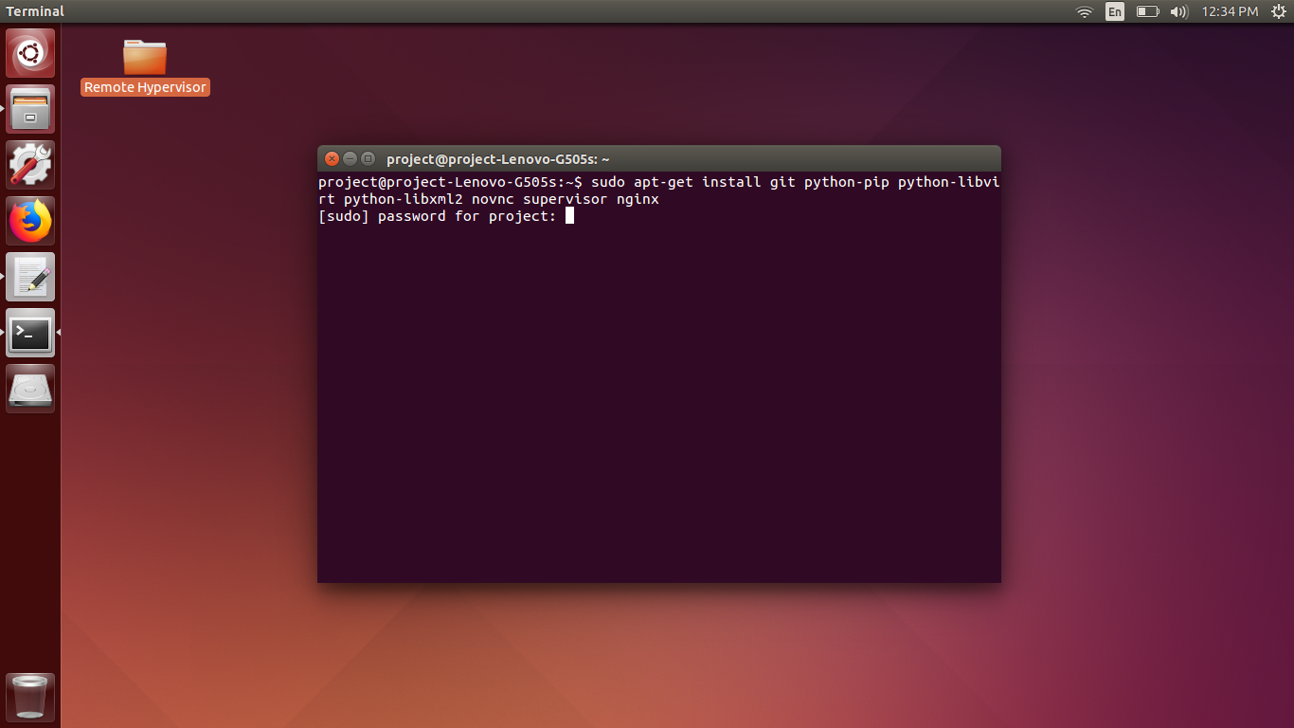

* In the above command,
  + “**git**” is an open source distributed version control system originally developed by Linus Torvalds to support the development of the linux kernel.
  + “**pip”** is a package management system used to install and manage software packages written in Python.
  + Many packages can be found in the default source for packages and their dependencies.
  + “**python-libvirt**” package provides a module that permits application written in the python programming language to call the interface supplied by the libvirt library, to manage the virtualization capabilities of recent version of linux.
  + “**python-libxml2**” is an xml package to implement the linking between the files of the virtualization system.
  + “**novnc**” is both HTML VNC client JavaScript library and an application built on top of that library.
  + NoVnc runs well in any modern web browser including mobile browsers (Apple’s iOS and Google’s Android).
  + “**supervisor**” is a client / server system that allows its user to monitor and control number of process on UNIX like operating system.
  + “**nginx**” is pronounced as “Engine X”. nginx is an open-source web server that is similar to Apache web server, but very light weight.
  + nginx is both web server and reverse proxy server.
  + Some of the Features of nginx or “Engine X” are:
    - * It serves static and index file.
      * Reverse proxy with catching.
      * Supports SSL.
      * Simple Load Balancing with Fault tolerance.
      * HTTP Basic authentication.
      * Supports Rewrite module

DOWNLOADING THE WEBVIRTMGR FILES:

* After all the utilities mentioned above is installed, clone or download the required file mentioned below with the help of following command
* “ **sudo** **git clone git://github.com/retspen/webvirtmgr.git** ”

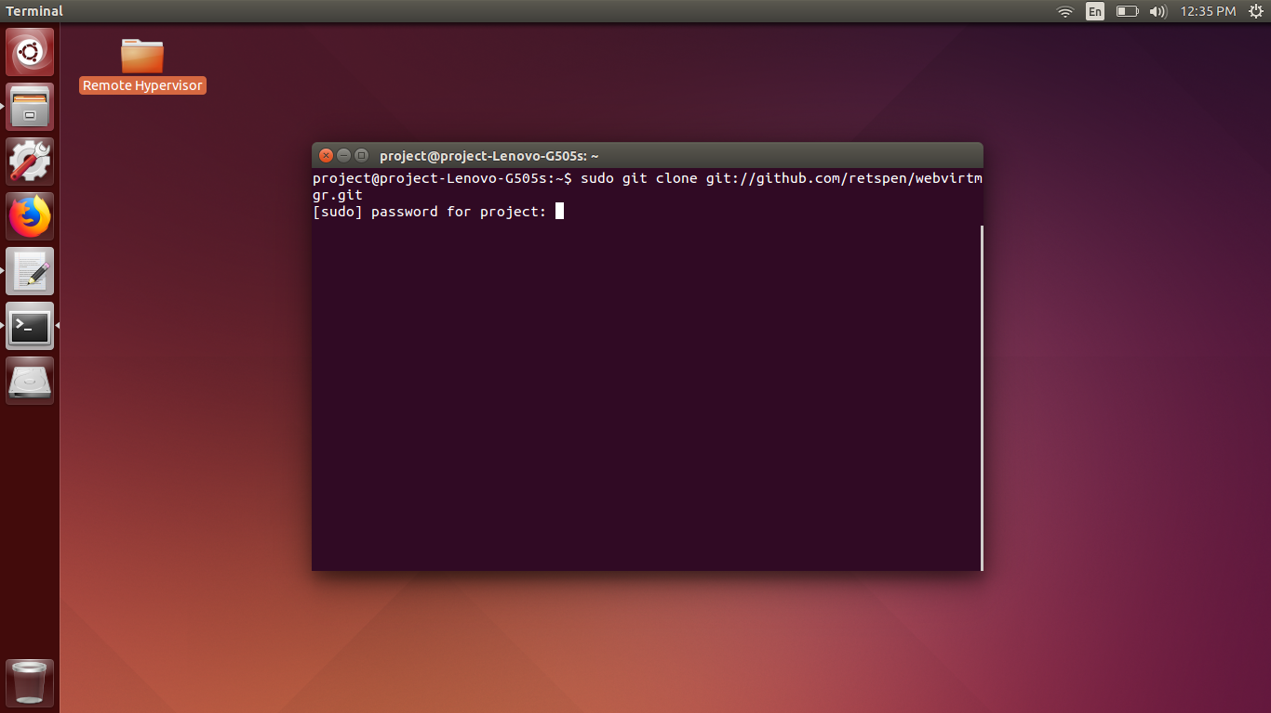

* In the above command,
* “**git**” is an open source distributed version control system originally developed by Linus Torvalds to support the development of the linux kernel.
* “**clone**” is used to download the files from the URL mentioned after the clone keyword.
* **“** **git://github.com/retspen/webvirtmgr.git ”** is the URL from which the file is to be downloaded.

CHANGE DIRECTORY TO WEBVIRTMGR:

* After the file gets downloaded , change the directory of the terminal to /home/project/webvirtmgr” by executing the following command “**cd webvirtmgr**”

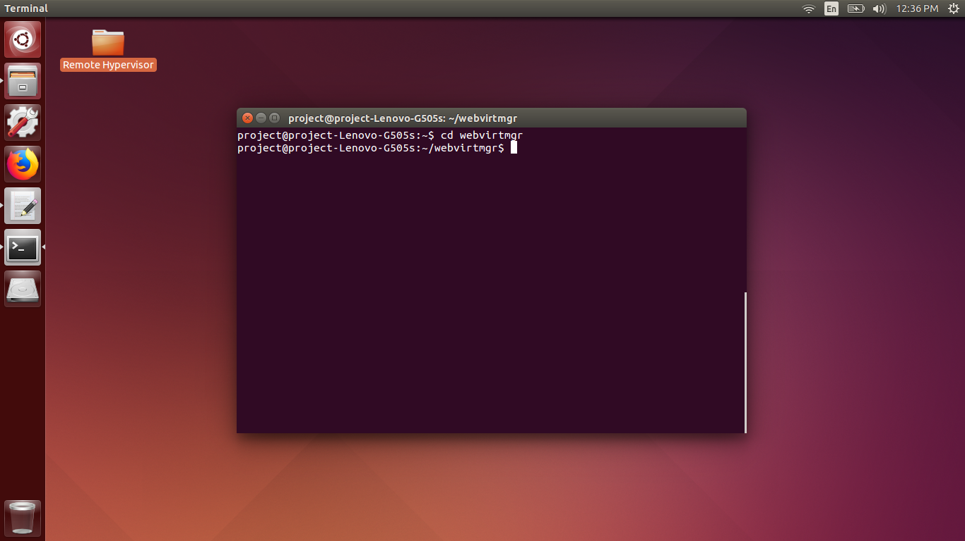

* In the above command,
* “**cd**” command is used to change the directory from current directory to the directory mentioned in the command.
* “**webvirtmgr**” is the directory in which we are going to switch the directory to access and execute the files in the directory named webvirtmgr.

INSTALLATION OF ALL THE REQUIRED CONFIGURATION:

* With the following command “**sudo** **pip install –r requirement.txt**”, all the configurations which are required by the system gets installed.

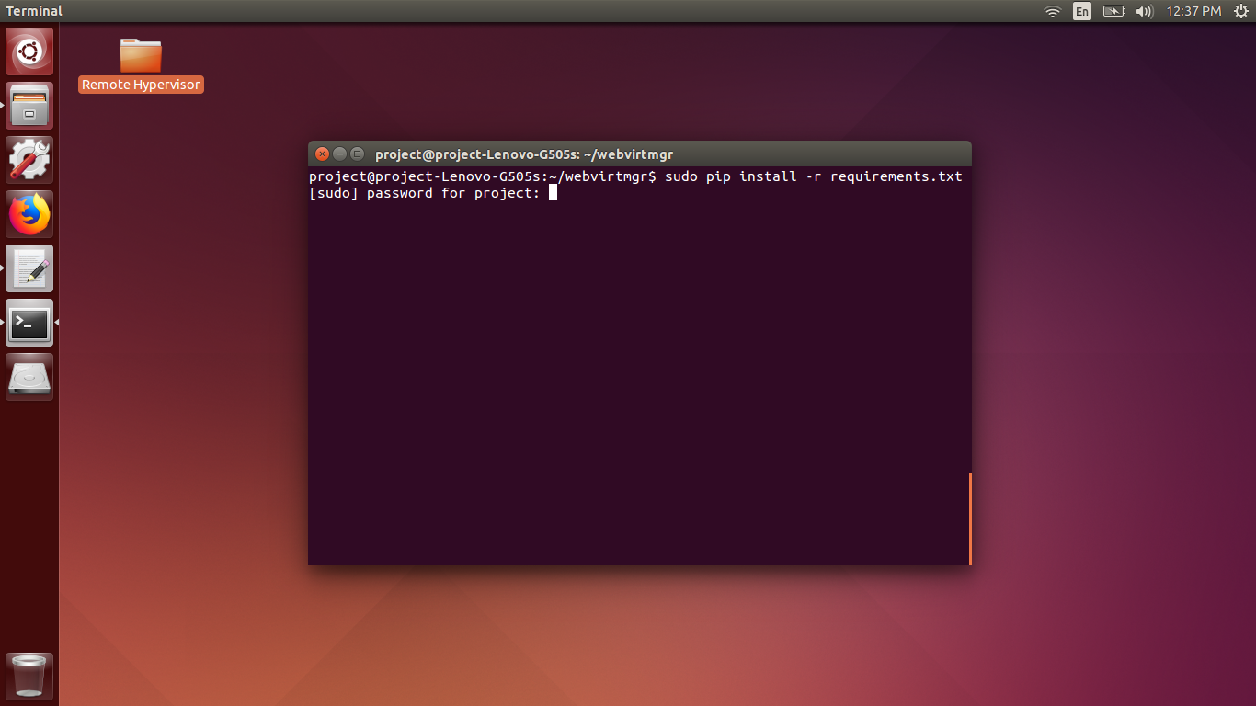

* **“pip”** is a package management system used to install and manage software packages written in Python.
* “**install**” keyword is used to install the configurations form the “ requirements.txt ” file.
* “**requirements.txt**” is the file which contains all the configurations which are going to be installed.
* Contents of “requirements.txt” file are:

django==1.5.5

gunicorn==18.0

# Utility Requirements

# for SECURE_KEY generation

lockfile>=0.9

# Uncoment for support ldap

#django-auth-ldap==1.2.0

SYNC THE SYSTEM WITH DATABASE:

* To sync the database with the system, executable manage.py file is required.
* This manage.py file can perform multiple operations on the system.
* The manage.py file is written in the Python language.
* To sync the database, run the following command, “ **sudo ./manage.py syncdb** ”

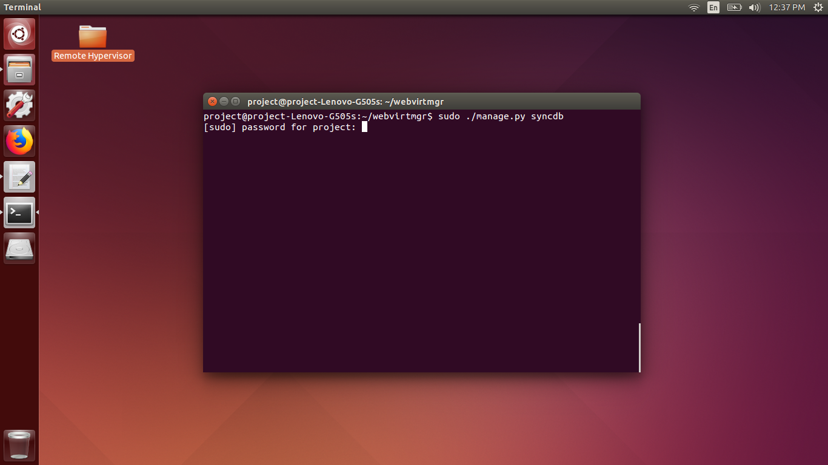

* Once the following command is executed, you will be presented with new options to create a user who is going to create and access the virtual machines.
* Just fill the details such as username, password, email id, etc required by the system.
* By doing this, the database will be get automatically synced with the system.

FORMATTING THE WEB PORTAL:

* To format the web page so that it is easily understandable by the end user, we have to run the following command, “ **sudo ./manage.py collectstatic** “.

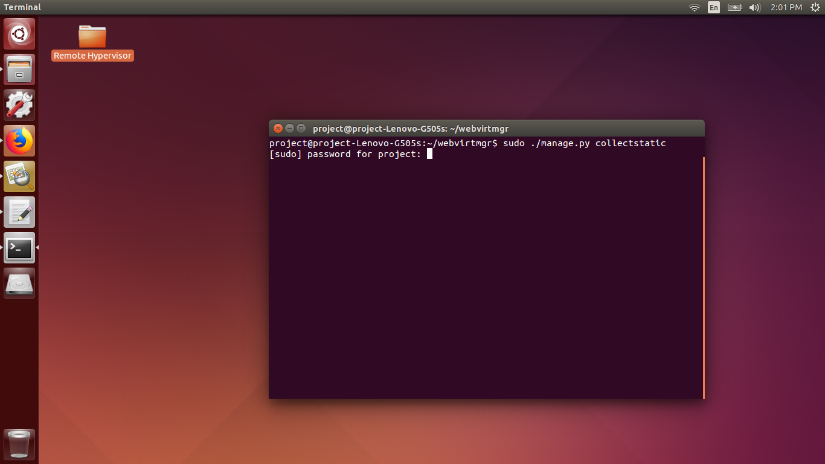

* In the above command,
* “ **collectstatic** ” is the file which contains all the formatting configurations of the web portal.
* By executing the above command, the plan HTML web page gets converted into great looking and easy to understand web page with all the bells and whistles.

CONFIGURE THE HTML DOCUMENTS AS PER REQUIREMENT:

* In this step we can configure the preconfigured HTML files of the system according to our requirements.
* The path of all the HTML files are “**/home/project/webvirtmgr/templates**”
* Run the following command to change directory into above location, “**cd /home/project/webvirtmgr/templates**”.
* In the above command, the “/home” is the home directory of all the users.
* “project” is the username of the user “project”.
* “webvirtmgr” is the directory in which all the necessary files for the web portal is present.
* “templates is the directory in which all the front end files are present.

CONFIGURING **console-vnc.html**:

* Console-vnc.html contains the front end part of the Console window.
* Part of HTML code which is to be configured,
* document.title = unescape(WebUtil.getQueryVar('title', **'VP Hypervisor'**));
* In the above part of the code, change the bold part of the code according to your requirement.

CONFIGURING **base_auth.html**:

* Base_auth.html contains the front end of the home page or index page which is first presented.
* Part of the HTML code which is to be configured.
* <a class=”navbar-brand” href=”{% url ‘index’ %}”>**VP Hypervisor**</a>
* In the above part of the code, change the bold part of the code according to your requirement.

CONFIGURING **base.html**:

* Base.html contains the front end of the login page which is the very first page which is presented.
* Part of the HTML code which is to be configured.
* <a class=”navbar-brand” href=”{% url ‘index’ %}”>**VP Hypervisor**</a>
* In the above part of the code, change the bold part of the code according to your requirement.

CONFIGURING **sidebar.html**:

* Sidebar.html file contains the front end sidebar menu options such as Instance, Storage, networks, Interfaces, and secrets.
* Part of the code which is to be configured,

<li>

<a href="{% url 'secrets' host_id %}"

class="list {% active request "^/secrets" %}">{% trans "Secrets" %}</a>

</li>

* Remove the above lines of code from the sidebar.html file.
* Other files which can be configured as per requirements are :
  + Networks.html
  + Instance.html
  + Instances.html
  + Interfaces.html
  + Create.html
  + Storages.html
* To add the virtual image files for the guest operating system, Download the .VMDK image file of any of the operating system and copy it in the directory “**/var/lib/libvirt/images**”
* .VMDK files are virtual disk images which runs directly without the installation of the virtual operating system.

START ALL NECESSARY SERVICES:

* To run the webserver and its services, change directory to /home/project/webvirtmgr and execute the following command, “**sudo ./manage.py runserver 192.168.0.106:8008**”

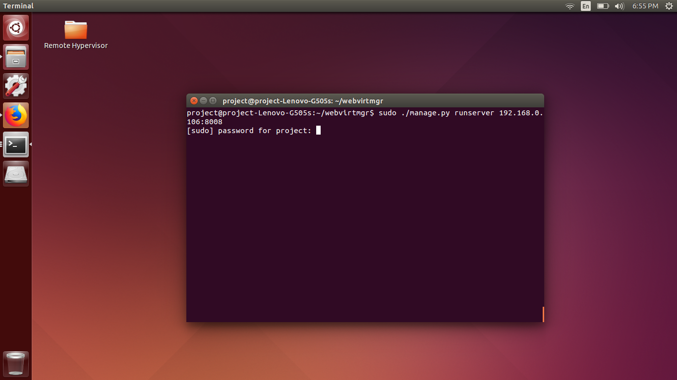

* In the above command, “**runserver**” is the which is used to start the execution of the webserver at specified IP address and port number.
* “**192.168.0.106:8008**” is the IP address and port number at which the server is going to be started.
* Since the server runs on at the particular IP address, it can be accessed from any location with the help of the web browser.

START THE NOVNC SERVER FOR CONSOLE WINDOW:

* When the virtual machine is created and started, we must be able to access the virtual machine.
* To do so, NoVnc Server is used and hence it needs to be started so that we can access the server.
* Open an another terminal window and change directory to “**/home/webvirtmgr/console**” and execute the following command

“**sudo ./webvirtmgr-console 9009**”.

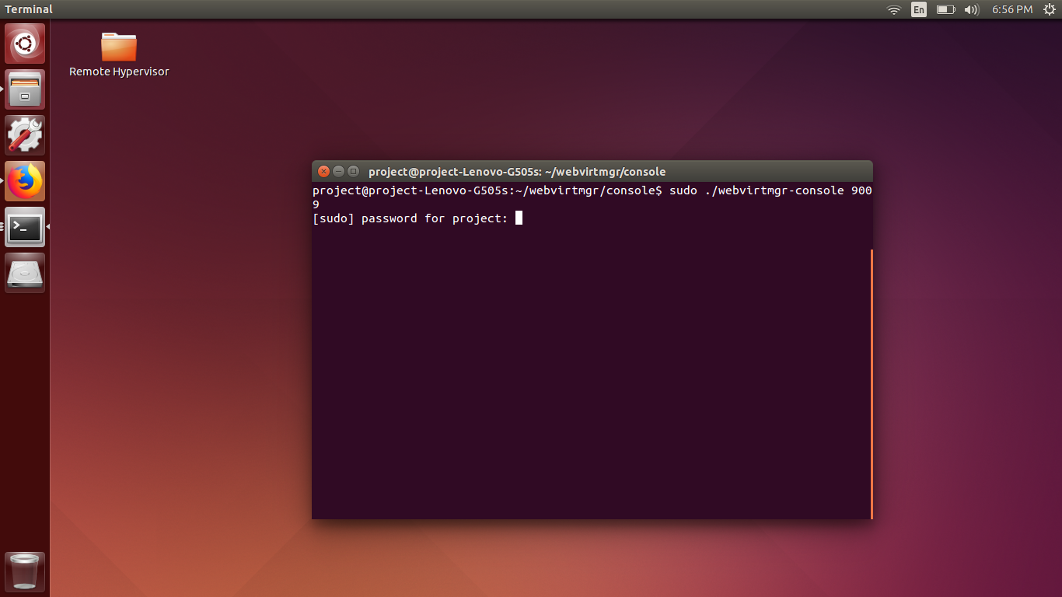

* In the above command, “**webvirtmgr-console**” is used to run the console service of the virtual machine, it is a type of NoVnc server.
* “**9009**” is the port number at which the Console service is running.

6.4.1] OUTPUT OF OUR PROJECT:

* Type the IP Address and the Port number on the web browser and then you will be greeted with the following page.
* The first screen which is going to be presented is the LOGIN page.

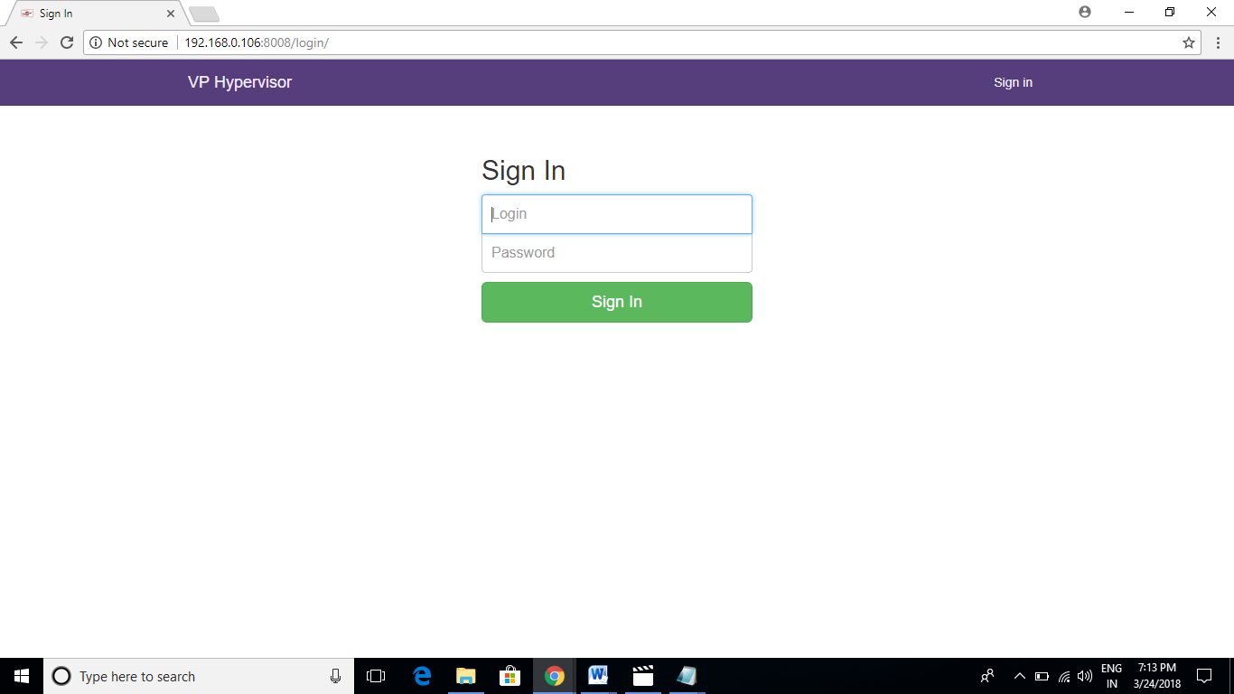

* Enter the username and password created at the time of syncing the database i.e “./manage.py syncdb” command.
* Once the Username and password is entered, click on Sign in button to enter the homepage or the index page of the system.
* This screenshot is taken from a windows 10 machine hence it is possible to access the server from remote location with the help of IP address.
* This tells that our server is a linux server but we are accessing it on a windows machine, hence it is platform independent.

HOMEPAGE:

* Initially, you wont have any connection like in the snapshot below.

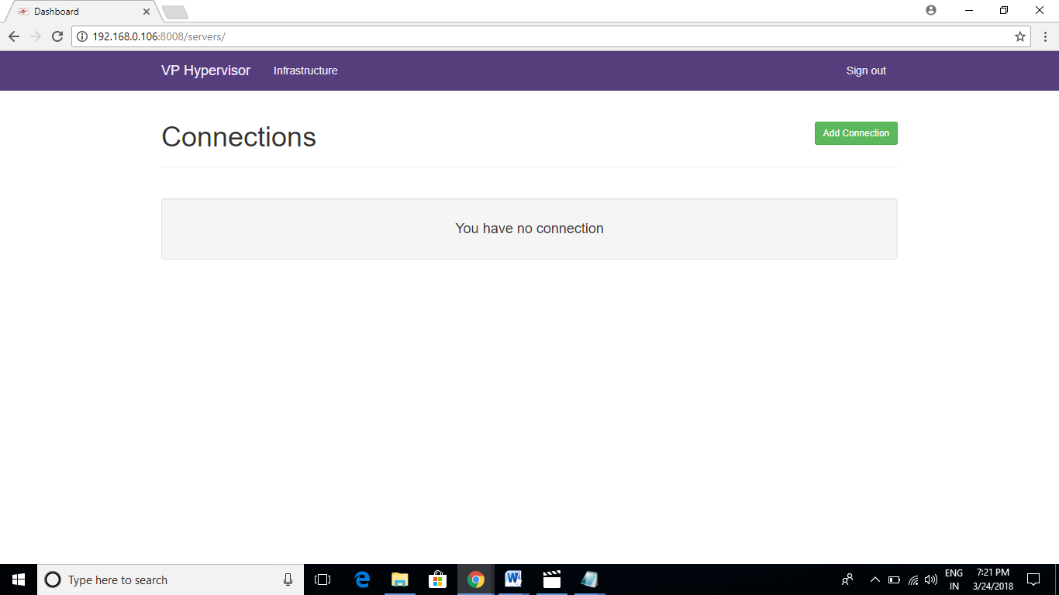

* Click on “Add Connection” to create a new connection.
* A connection is an infrastructure of your virtual environment.
* On the next step, click on Local Socket, since we are doing this demonstration in a Local environment.

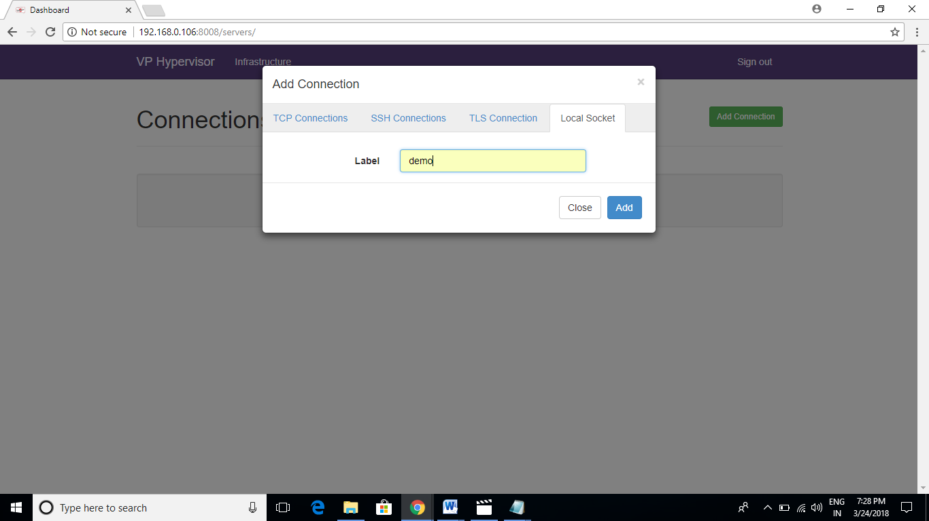

* Enter a Label name like we have entered “**demo**” and click on “Add”.
* Once you have clicked on “Add” , you will be presented with the next screen.

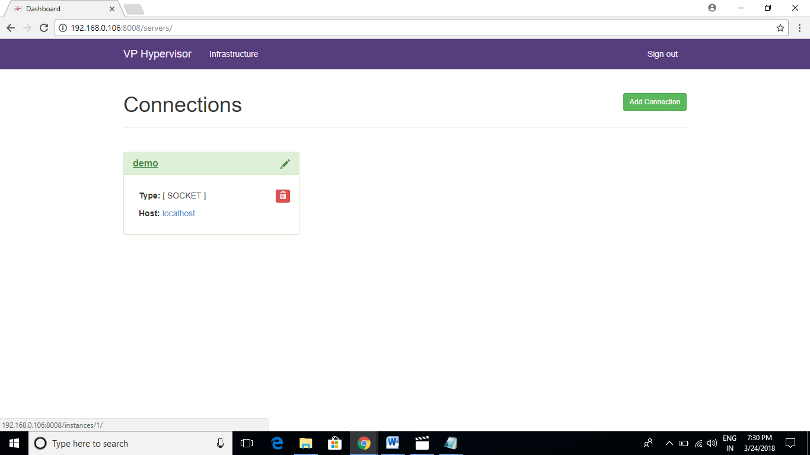

* Click on “demo” to view the virtual infrastructure environment.
* The next screen will be the empty infrastructure.

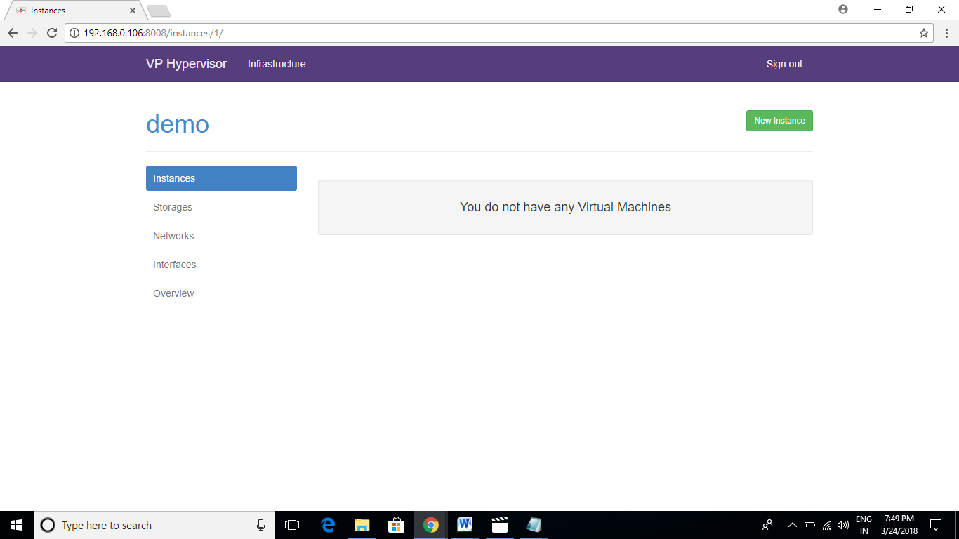

* Click On “**New Instance**” on the above snapshot.
* You will be presented with next screen to choose a particular instance.
* An instance is also known as a guest machine or virtual machine.

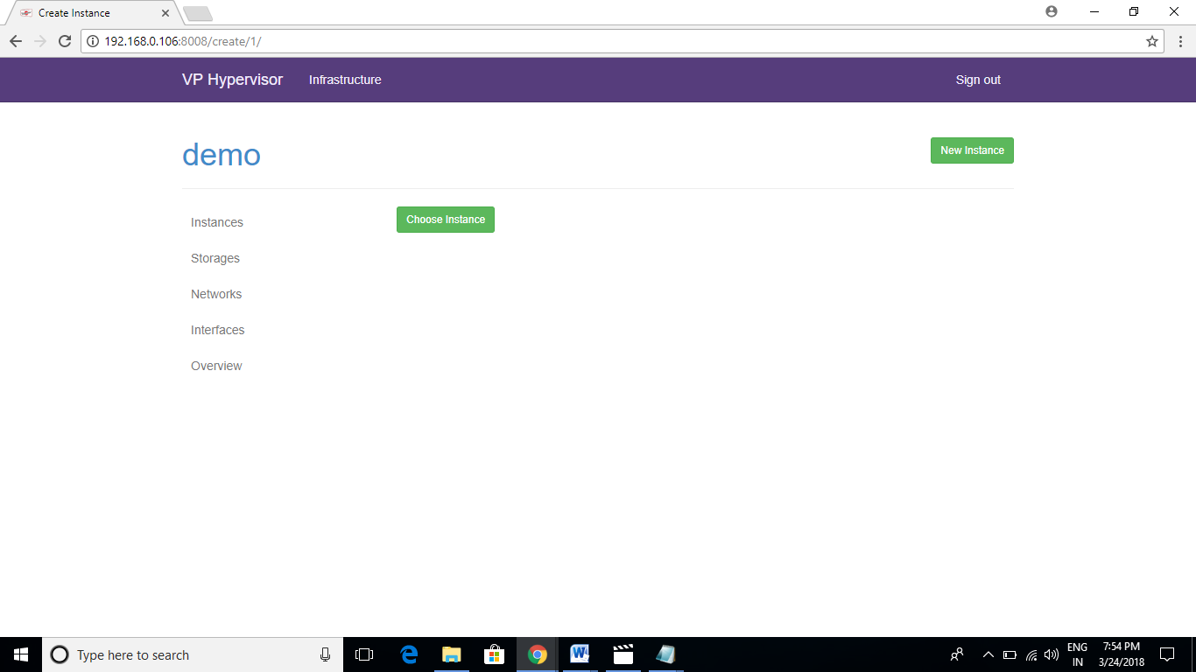

* Click on “**Choose Instance**”.
* On the next screen, select the configuration of virtual machine as required and than click on “**Create**”.

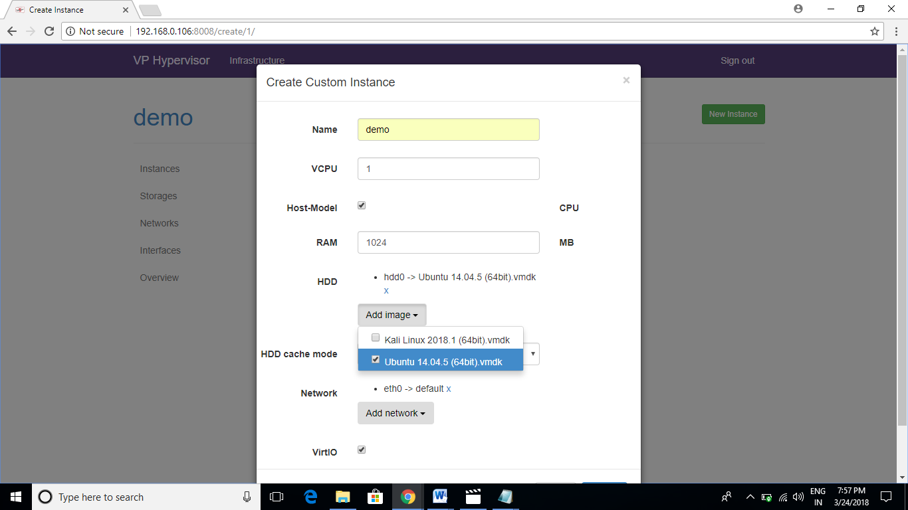

* Once the virtual machine is created, we can see the status of virtual machine in the Instances tab in the sidebar menu like in the snapshot below.

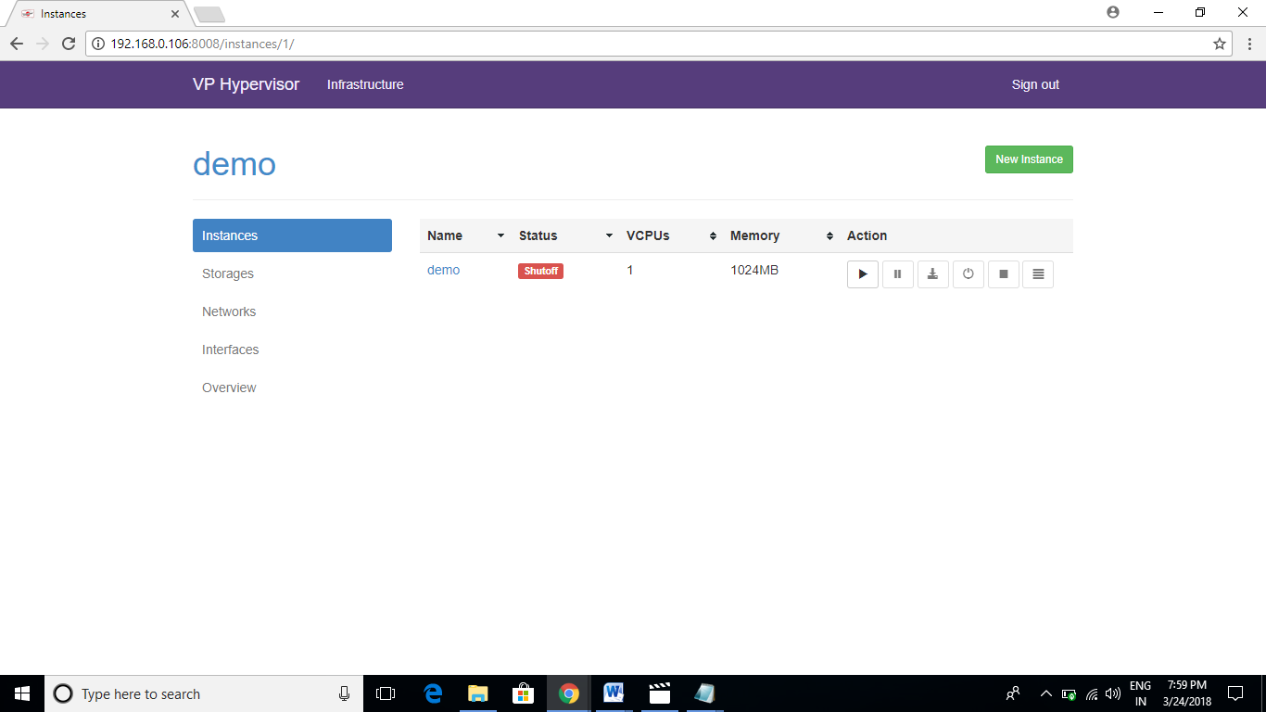

* In the above snapshot, a virtual machine is created with the name demo having the Ubuntu operating system and the status of the virtual machine is “shut off”.
* To run or start the virtual machine, click on start button as mentioned in the below snapshot.



* Once the virtual machine starts running, the status of the virtual machine becomes “**Running**” as mentioned in the below screenshot.

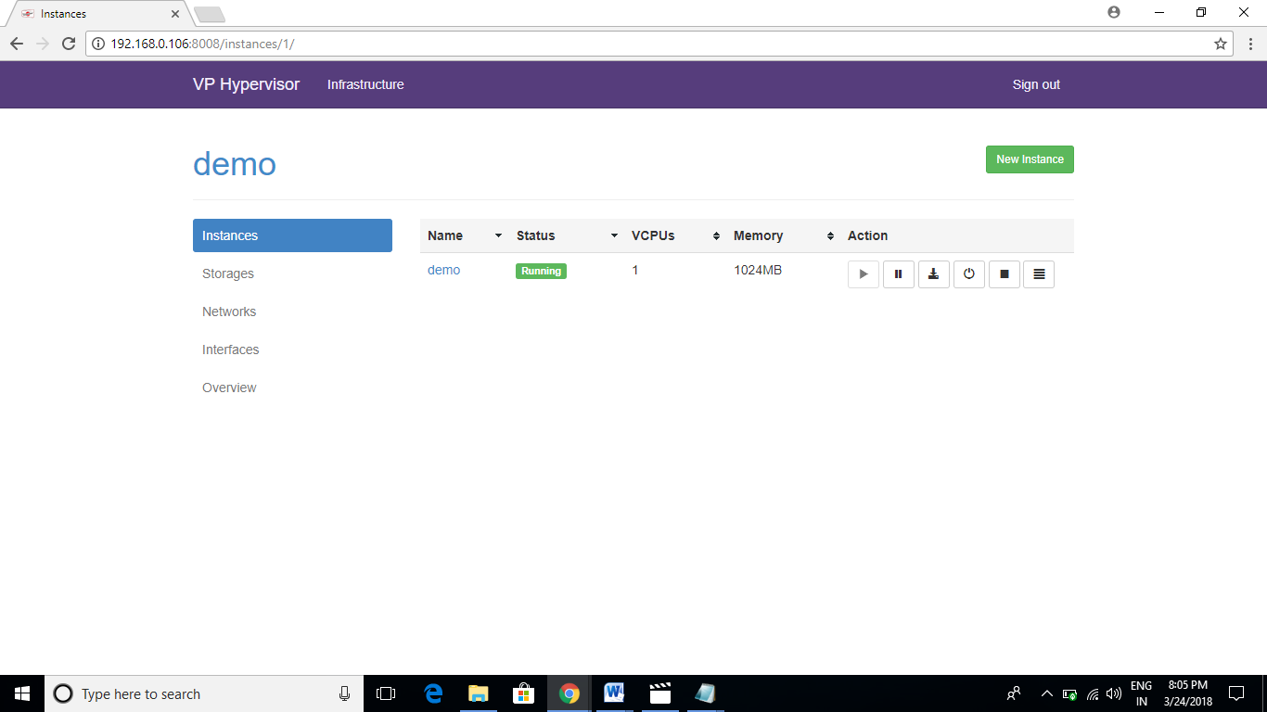

* To access the virtual machine, click on console button as mentioned below.

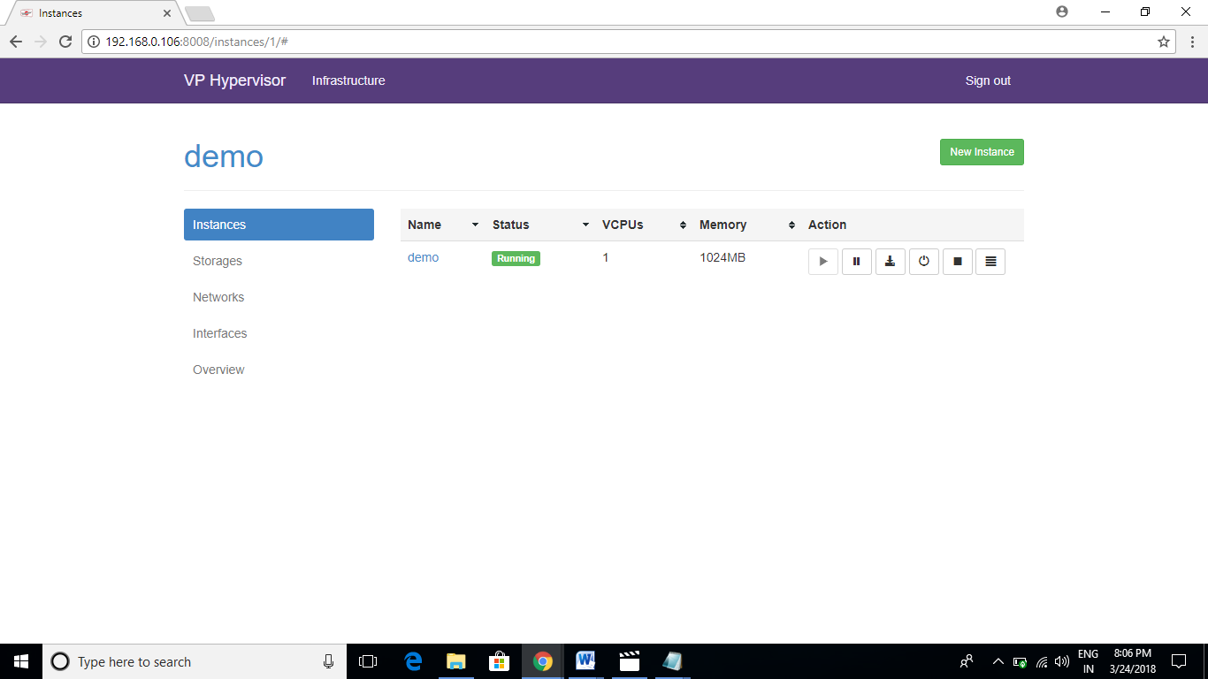

* By clicking on the console button, a new window will pop with the view of the running virtual machine or instance.
* Once clicked on the console button, you will be presented with the similar console window like below.

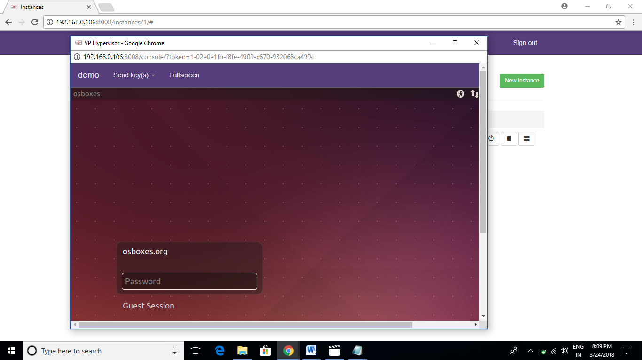

* As you can see, the console window is running an Ubuntu operating system displaying the login page of the Ubuntu system.
* By clicking on the Fullscreen button, you can have the full screen view of the console window like mentioned below.

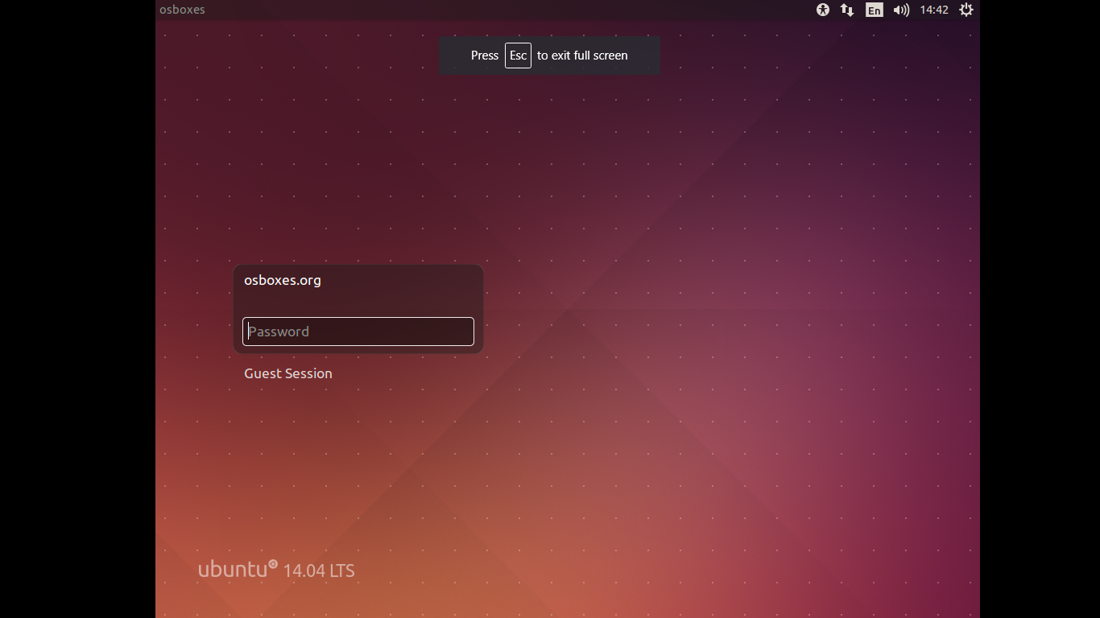

* To Shutdown a Virtual Machine, click on “**Force Shutdown”.**

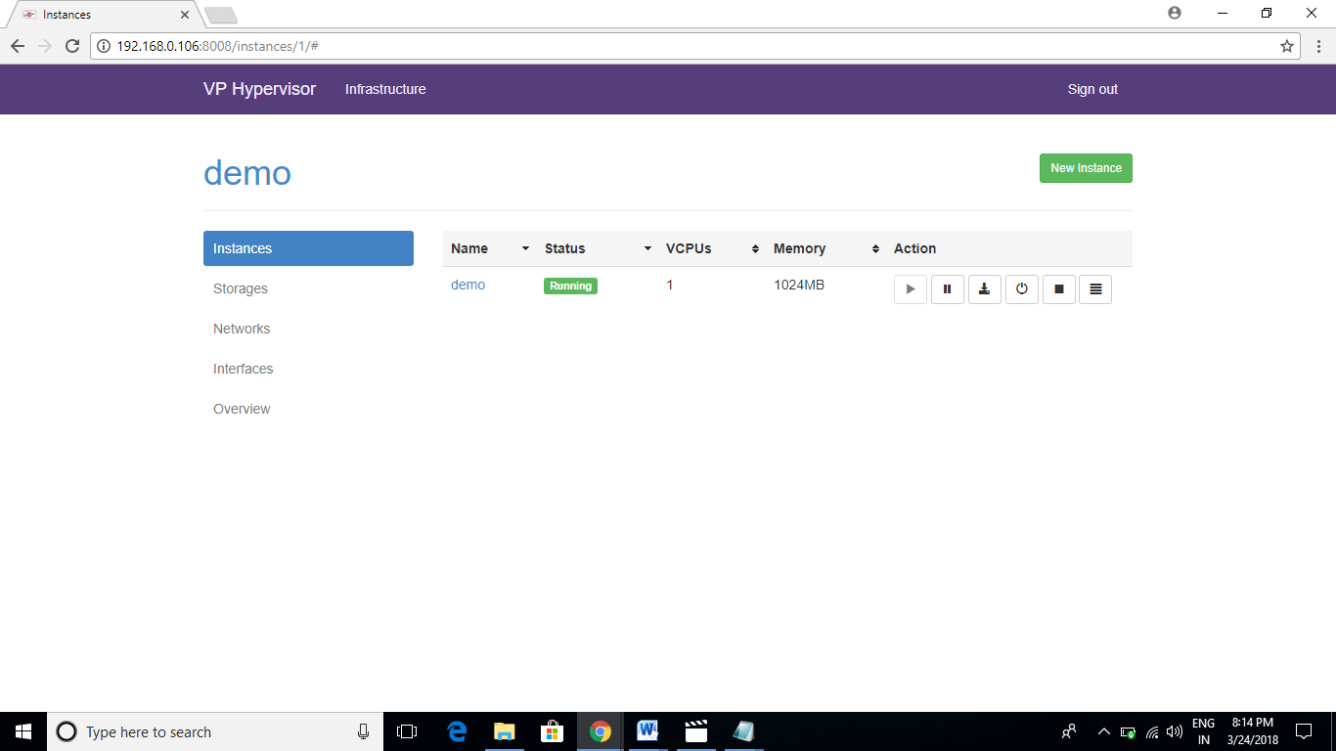

* By clicking on the Force Shutdown button, the virtual machine gets shutdown and the status of the machine again becomes shut off as

mentioned below.

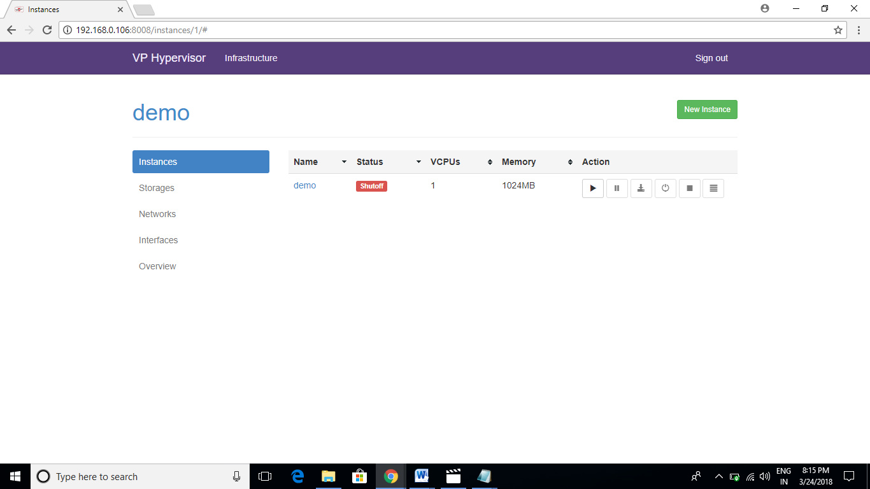

* For all the details of the virtual machine, click on the name of the virtual machine like below.



* Once clicked, you will be presented with the following screen.

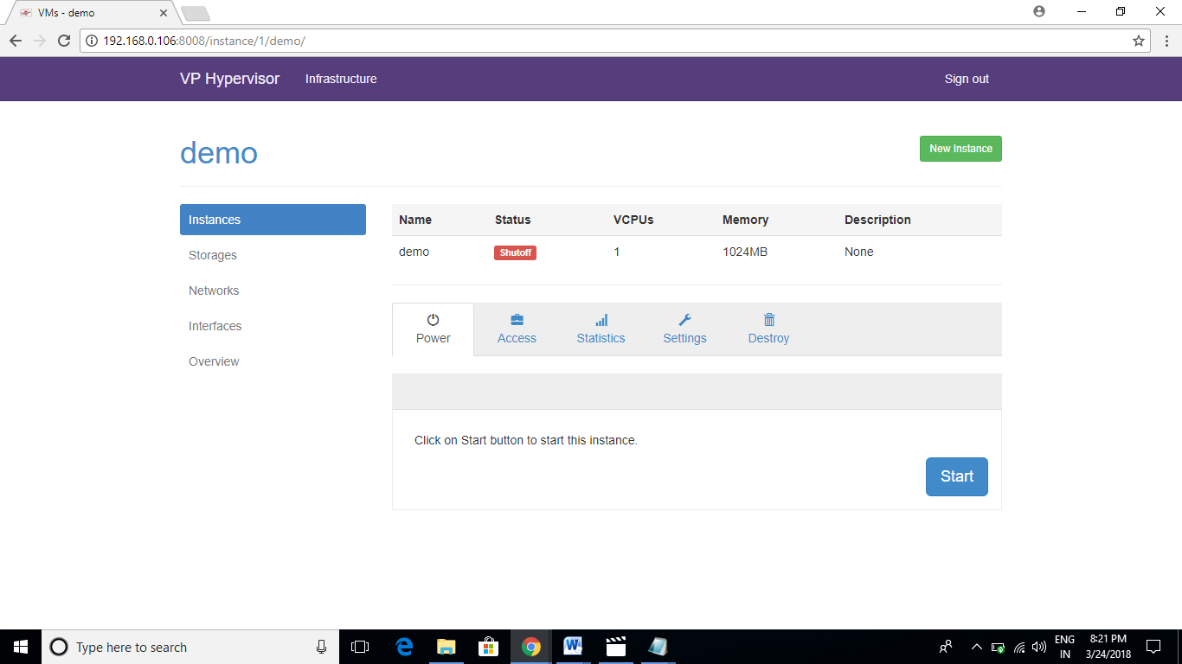

* To destroy the virtual machine, click on **Destroy** tab and than click on “**Delete**”

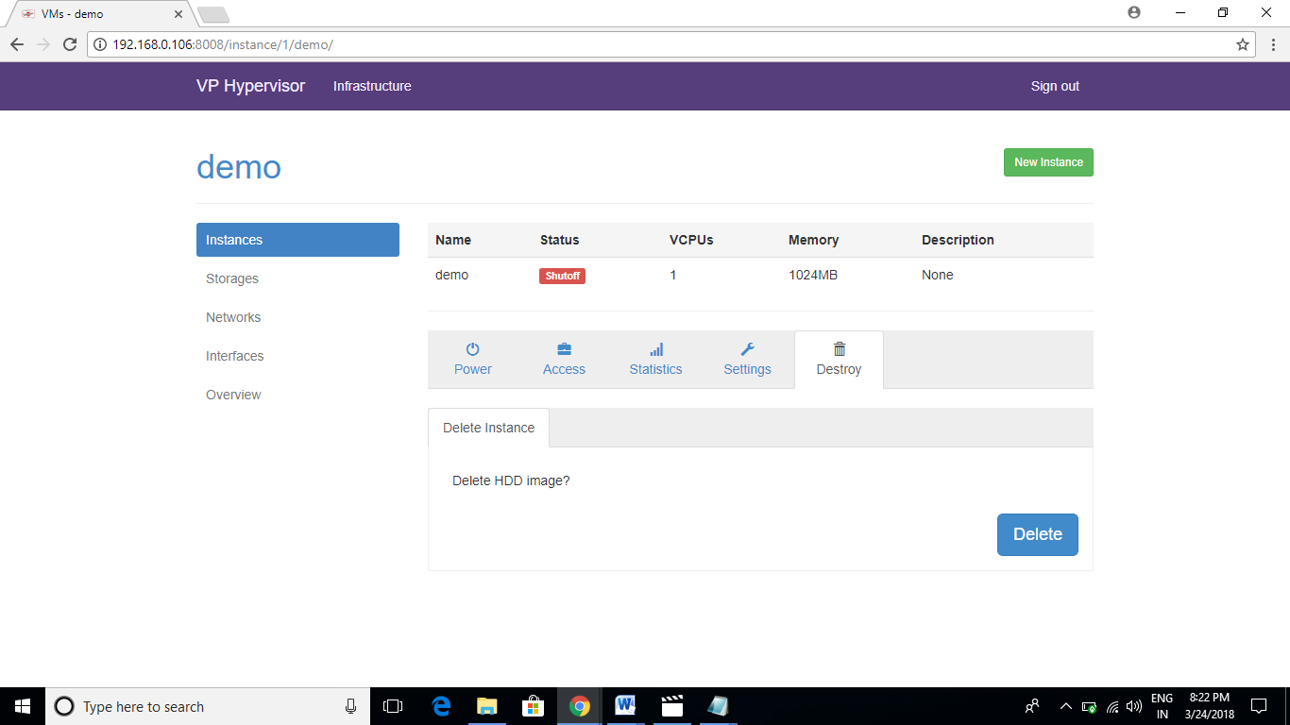

* To view the “**Storage**” information, click on Storage tab in the sidebar menu.

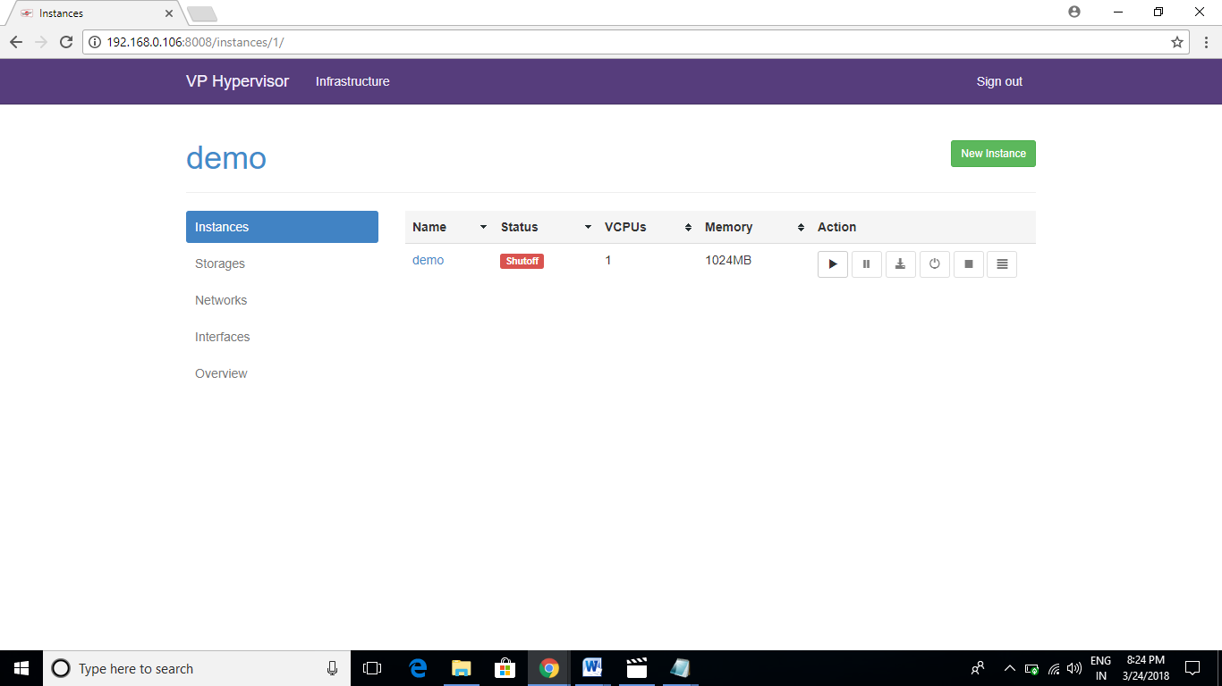

* Once clicked on the Storage tab, you will be presented with the following screen.

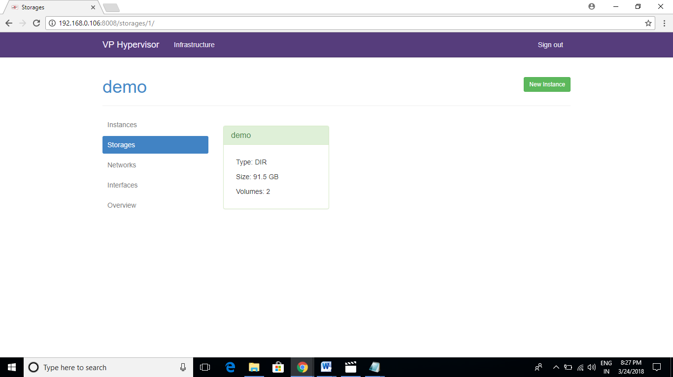

* In the above screen, “demo” is the name of the virtual machine, and available storage for demo virtual machine is displayed.
* To view the network properties of the virtual machine, click on the “**Networks**” tab in the sidebar menu.

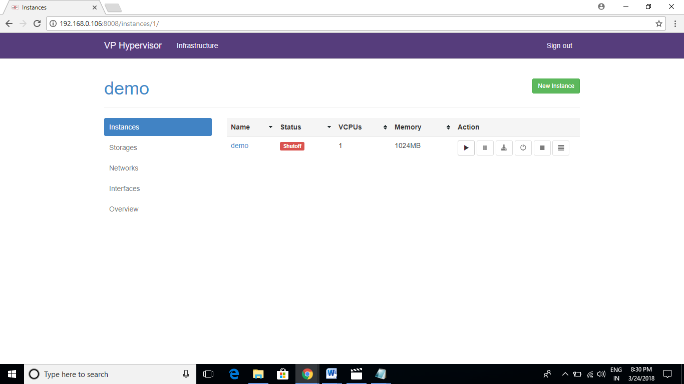

* Once clicked on the Networks tab, you will be able to see the virtual network properties as mentioned below.

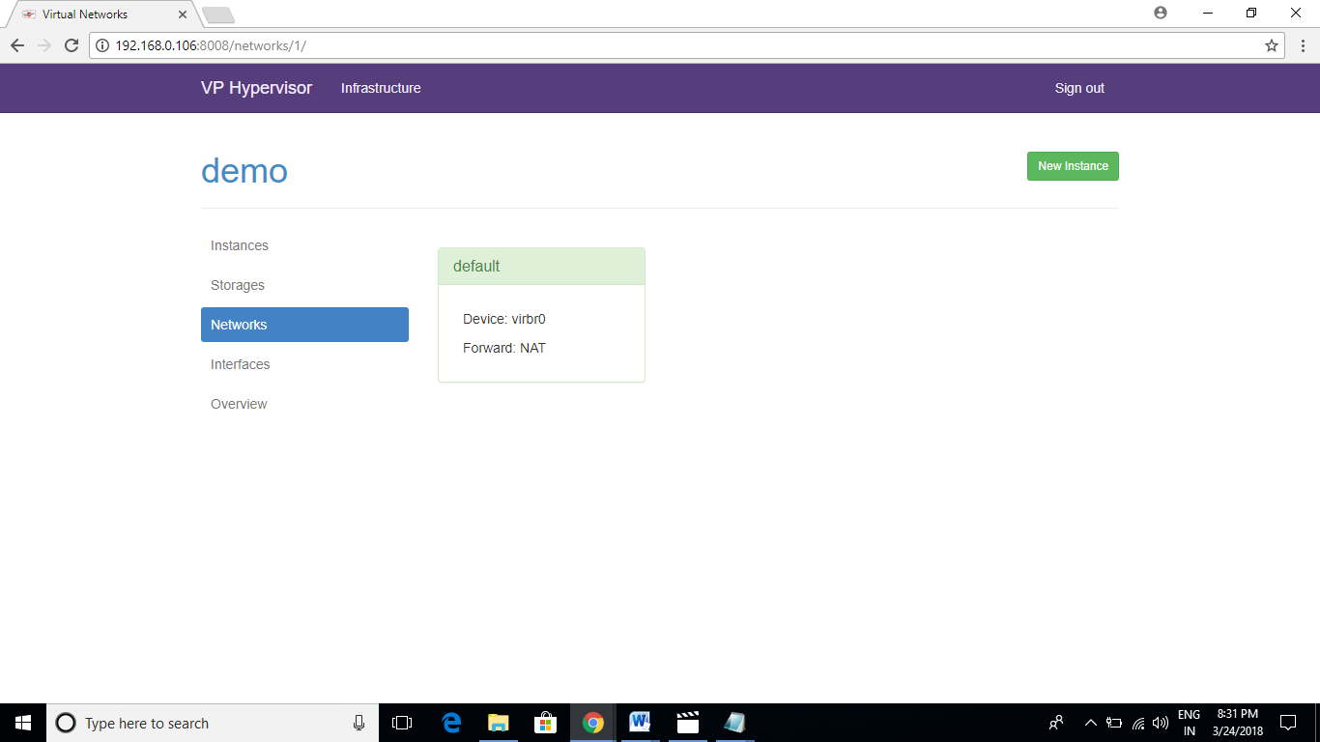

* To view the virtual “**Interface**” properties, we have to click on the Interfaces tab on the sidebar menu.

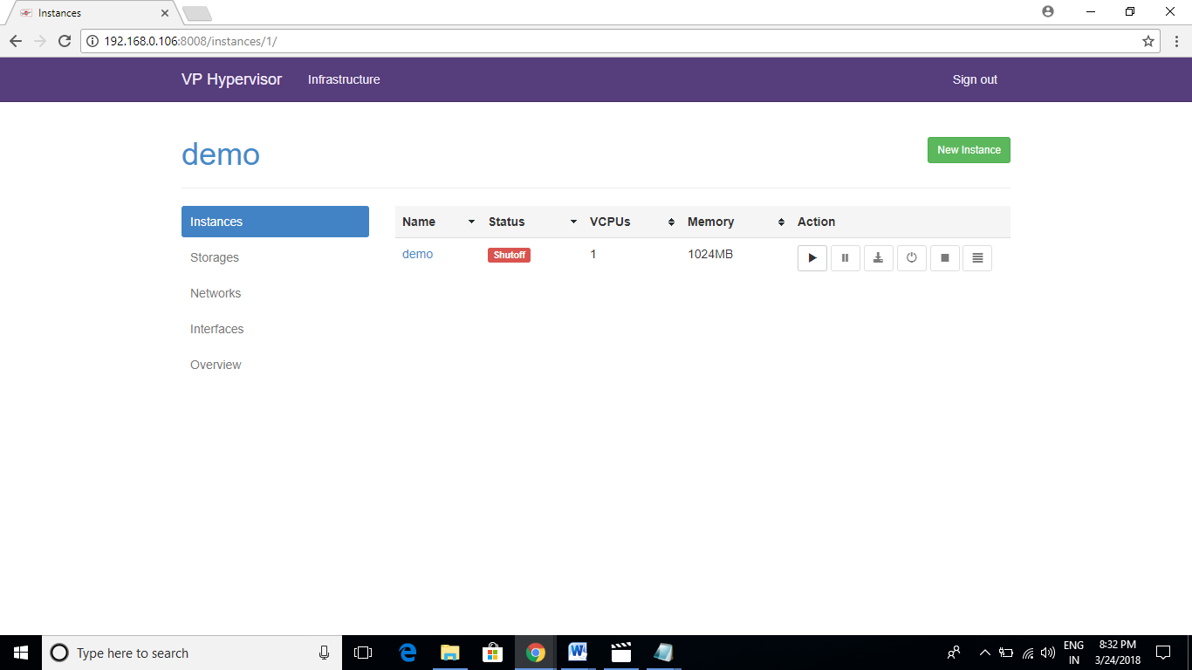

* Once clicked, you following screen will appear as mentioned below.

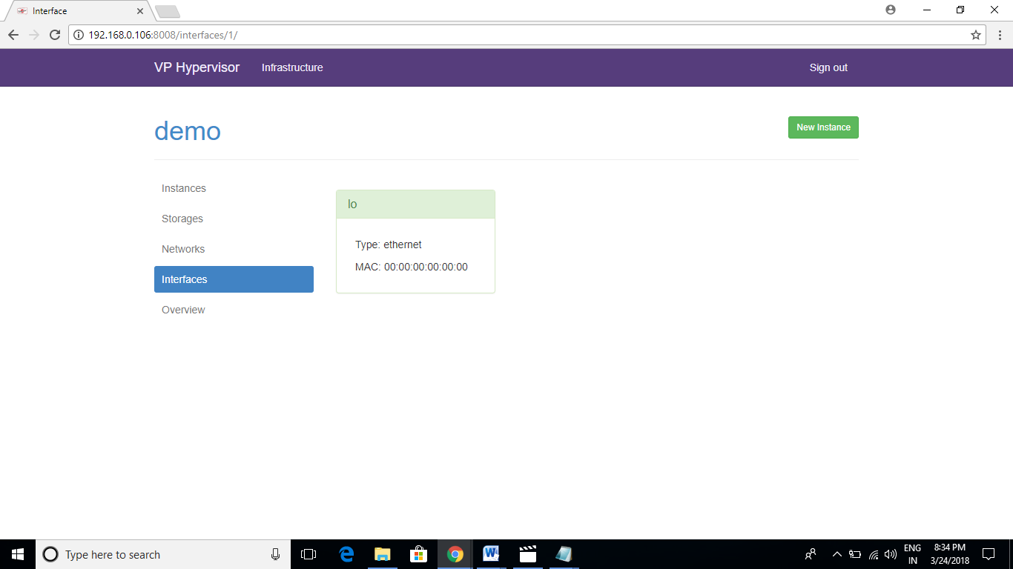

* To view the “**Overview**” of the host machine, click on the Overview tab in the sidebar menu.

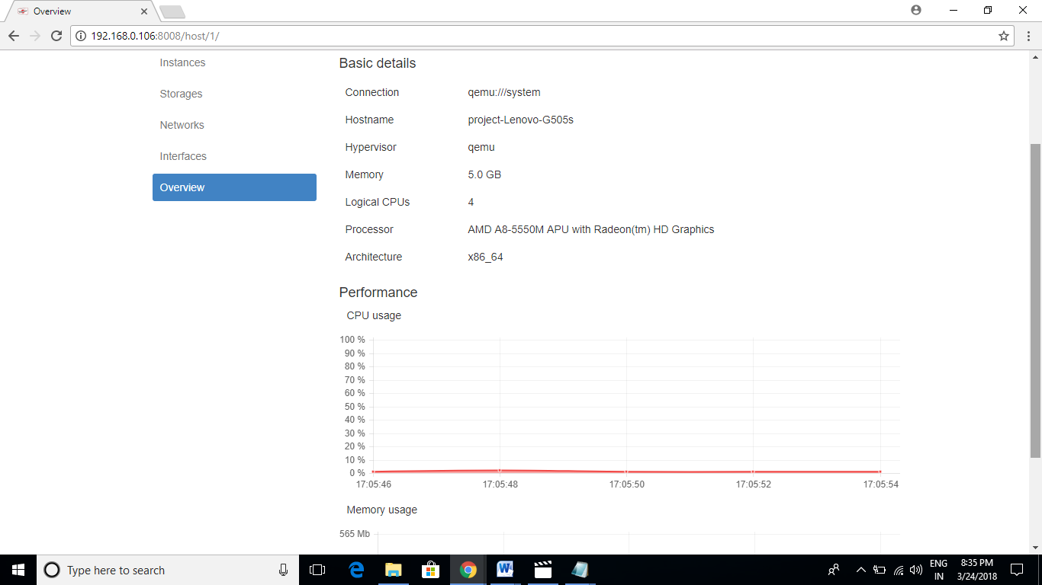

**TESTING AND RESULT**

CHAPTER 7

TEST PLAN AND TEST ACTIVITIES:

7.1] TEST PLAN:

A test plan can be defined as a document describing the scope, approach, resources, and schedule of intended testing activities. It identifies test items, the features to be tested, the testing tasks, who will do each task, and any risks requiring contingency planning. In software testing, a test plan gives detailed testing information regarding an upcoming testing effort, including

* Scope of testing
* Schedule
* Test Deliverables
* Release Criteria
* Risks and Contingencies

It is also be described as a detail of how the testing will proceed, who will do the testing, what will be tested, in how much time the test will take place, and to what quality level the test will be performed.

The process of defining a test project so that it can be properly measured and controlled. The test planning process generates a high level test plan document that identifies the software items to be tested, the degree of tester independence, the test environment, the test case design and test measurement techniques to be used, and the rationale for their choice. A testing plan is a methodological and systematic approach to testing a system such as a machine or software. It can be effective in finding errors and flaws in a system. In order to find relevant results, the plan typically contains experiments with a range of operations and values, including an understanding of what the eventual workflow will be.

Test plan is a document which includes, introduction, assumptions, list of test cases, list of features to be tested, approach, deliverables, resources, risks and scheduling. A test plan is a systematic approach to testing a system such as a machine or software. The plan typically contains a detailed understanding of what the eventual workflow will be. A record of the test planning process detailing the degree of tester independence, the test environment, the test case design techniques and test measurement techniques to be used, and the rationale for their choice.

7.2] TEST ACTIVITIES:

Various Testing Activities are as follow:

* BLACK BOX TESTING:

Internal system design is not considered in this type of testing. Tests are based on requirements and functionality.

* WHITE BOX TESTING:

This testing is based on knowledge of the internal logic of an applications code. Also known as Glass box Testing. Internal software and code working should be known for this type of testing. Tests are based on coverage of code statements, branches, paths, conditions.

* UNIT TESTING:

Testing of individual software components or modules. Typically done by the programmer and not by testers, as it requires detailed knowledge of the internal program design and code. May require developing test driver modules or test harnesses.

To perform a unit testing, we had performed tests on individual module such as the OS module.

* INCREMENTAL INTEGRATION:

Testing Bottom up approach for testing i.e continuous testing of an application as new functionality is added; Application functionality and modules should be independent enough to test separately. done by programmers or by testers.

We have performed incremental testing by performing tests on incremented modules such as the OS module and the network module..

* INTEGRATION TESTING:

Testing of integrated modules to verify combined functionality after integration. Modules are typically code modules, individual applications, client and server applications one network, etc. This type of testing is especially relevant to client/server and distributed systems.

To perform integration testing, we had performed several combined test such as combined testing of OS module and network module.

* FUNCTIONAL TESTING:

This type of testing ignores the internal parts and focus on the output is as per requirement or not. Black-box type testing geared to functional requirements of an application.

We have also performed functional testing by performing tests on the system to check the functionality of the system.

* SYSTEM TESTING:

Entire system is tested as per the requirements. Black-box type testing that is based on overall requirements specifications, covers all combined parts of a system.

Once the development of our project is done, we have performed the System testing by testing the entire system as a whole.

* END-TO-END TESTING:

Similar to system testing, involves testing of a complete application environment in a situation that mimics real-world use, such as interacting with a database, using network communications, or interacting with other hardware, applications, or systems if appropriate.

* ACCEPTANCE TESTING:

Normally this type of testing is done to verify if system meets the customer specified requirements. User or customers do this testing to determine whether to accept application.

* USABILITY TESTING:

User**-**friendliness check. Application flow is tested, Can new user understand the application easily, Proper help documented whenever user stuck at any point. Basically system navigation is checked in this testing.

To test the usability of our system, we have performed the usability testing so that it becomes easy for en user to understand our system.

7.3] RESULTS:

SNAPSHOTS OF THE RESULTS:

LOGIN SCREEN:

This is the login screen to authenticate the user.

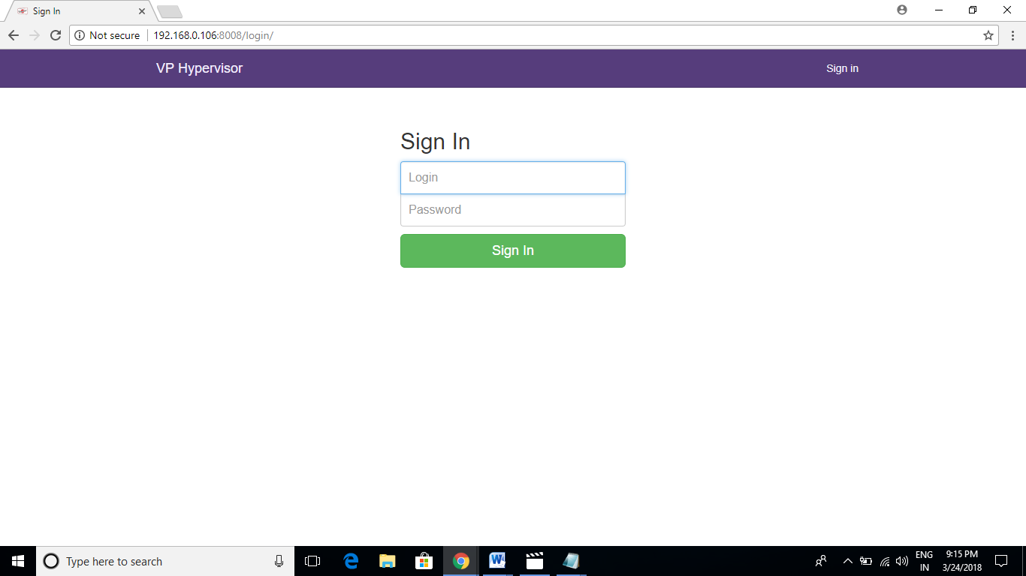

AVAILABLE CONNECTIONS:

This page shows the available connections or virtual infrastructure.



HOMEPAGE:

This is the homepage or index page of our system.

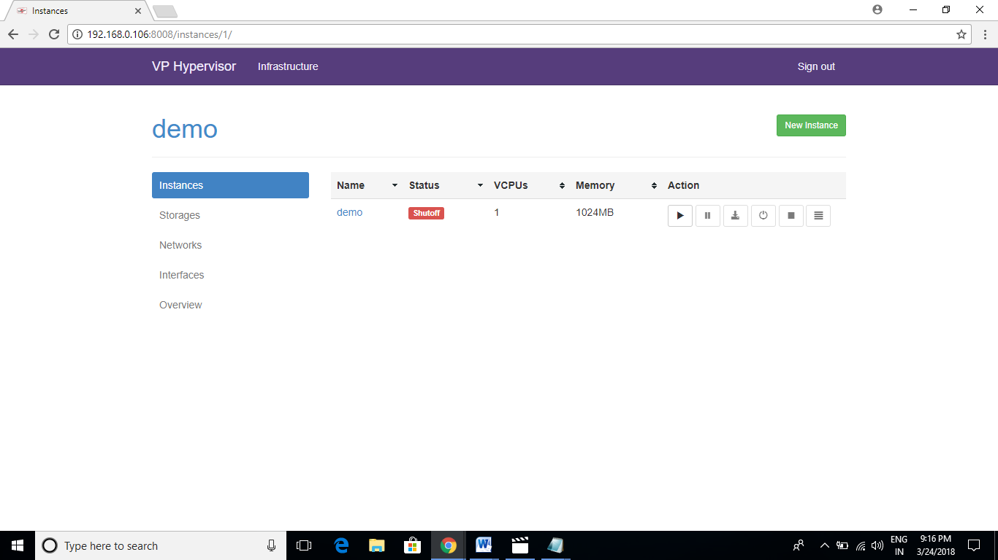

NEW INSTANCE SCREEN:

This page is used to create new virtual machines or instances.

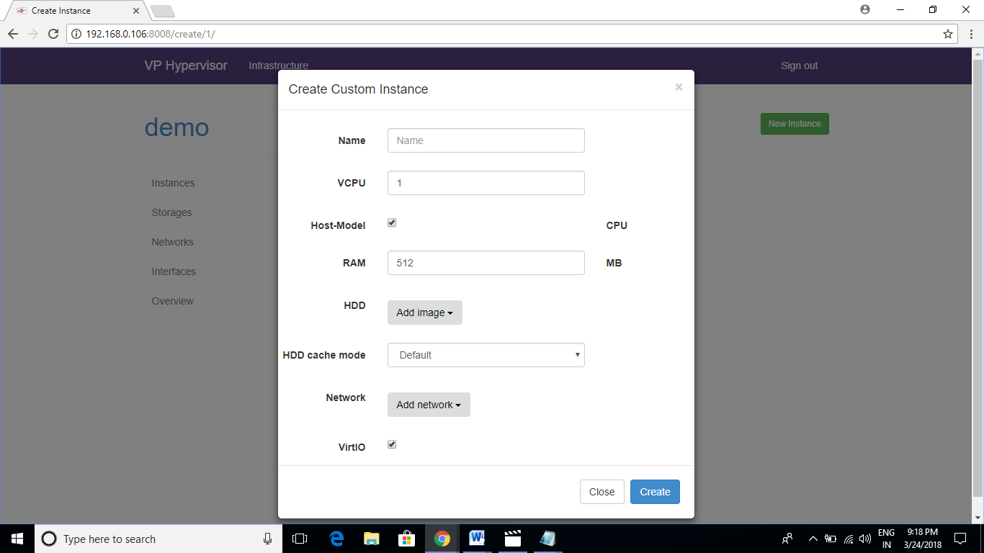

DETAILED VIRTUAL MACHINE INFORMATION:

This page shows the detailed information of the virtual machine.

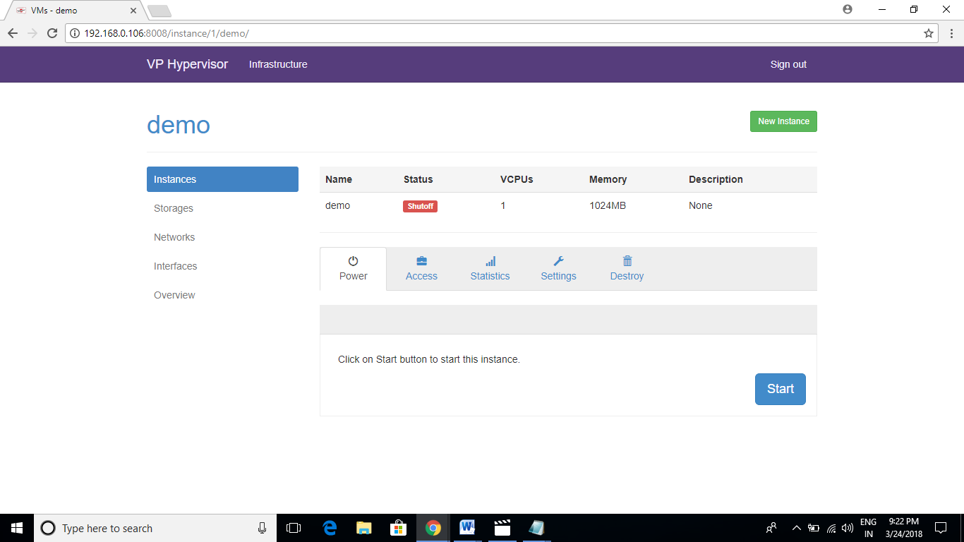

OVERVIEW OF THE HOST MACHINE:

This screen show the overview of the host machine.

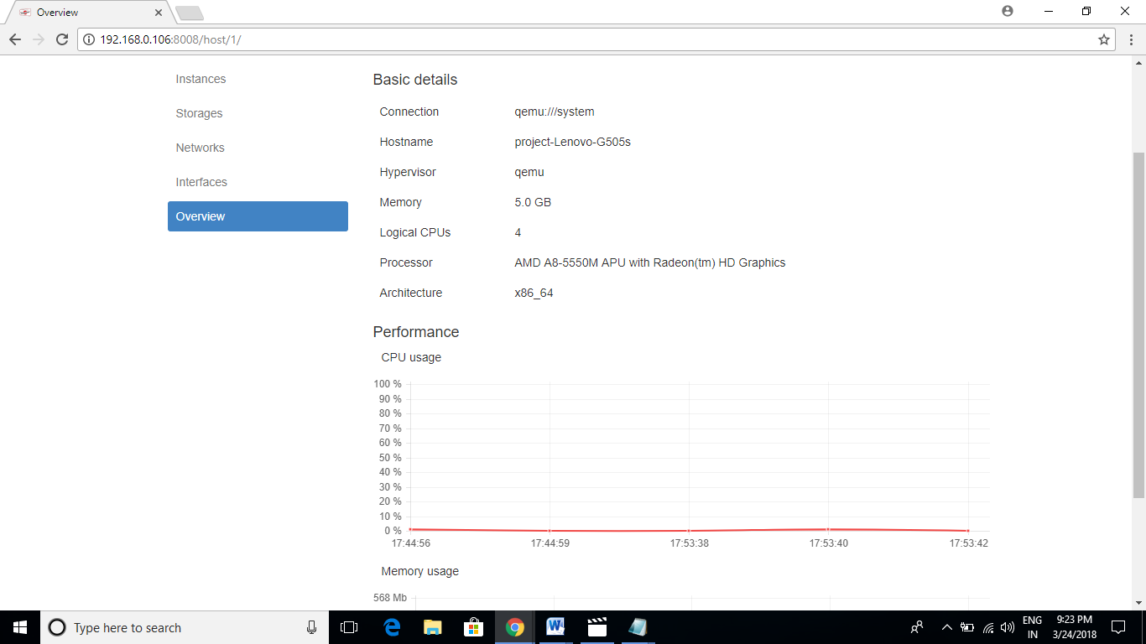

**FEASIBILITY ANALYSIS**

## CHAPTER 8

## 8.1] FEASIBILITY STUDY

Feasibility study is a test of system proposal according to the workability, impact on the organization, ability to meet user needs and effective use of the available resources. The objective of feasibility study is not to solve the problem but to acquire a sense of its scope.

TECHNICAL FEASIBILITY:

Technical feasibility centers on the existing system and to what extent it can support the proposed system. The benefits such as high accuracy, minimum response time and user friendliness of the proposed system over weights cost for designing and implementing the new system.

BEHAVIORAL FEASIBILITY:

It includes how strong the reaction of the staff will be towards the development of the new system that involves computer use in their daily work. So resistant to change is identified.

OPERATIONAL FEASIBILITY:

It is concerned with human, organizational and political aspects. It includes in two ways:-

Technical Performance: It includes issues such as whether the system can provide the right information for the organization’s personnel at the right time and at the right place.

Acceptance within the organization: It determines the general attitudes and job skills of existing personnel and whether any changes in job work will be acceptable by the current users.

ECONOMICAL FEASIBILITY:

The purpose of assessing economic feasibility is to identify the financial benefits and cost associated with the development of the system. Economic feasibility is often known as the cost benefit analysis. To carry out an economic feasibility study it is necessary to estimate actual money value against activities needed for implementing the system.

**PROS AND CONS**

CHAPTER 9

9.1] ADVANTAGES:

* Build on Open-Source platform.
* Free of cost to implement.
* Virtual machines can be accessed on any remote location.
* Only web browser is required on the client machine.
* Client machine does not gets slow down.
* Platform independent.
* Easy to implement.
* Can be run on mobile devices.

9.2] DISADVANTAGES:

* Internet connection is required.
* Server Grade hardware is required.
* As number of users increases, hardware needs to be upgraded.
* If server fails, it may lead to disaster.
* Support for hypervisor systems are less.

**APPLICATIONS**

CHAPTER 10

:

10.1] SOME OF THE APPLICATIONS OF OUR PROJECT ARE:

* It can be an alternative to the traditional system of giving a physical laptop to an employee by an organization.
* Students can use virtual machines to understand different operating systems.
* It can also be used as a service given to whom it is required like an Internet Service Provider (ISP) does on a rental basis.

**FUTURE DEVELOPMENT**

CHAPTER 11

11.1] FUTURE DEVELOPMENT:

Future development of our project are:

* MORE STABILITY:
  + In future, the system can become more stable as new technologies comes in pictures.
  + Stability for mobile devices may be improved.
* IMPROVED SPEED:
  + In future, the speed of the system can be improved as the internet bandwidth gets increased and better internet connectivity is available.
  + As the speed of the internet gets increased, it will directly lead to increase in speed.
* IMPROVED EFFICIENCY:
  + The efficiency of the system can be improved to efficiently create and run the virtual machines.
  + As the efficiency of the system improves, stability and performance also gets improved.

**CONCLUSION AND BIBLIOGRAPHY /**

**REFERENCES**

CHAPTER 12

12.1] CONCLUSION:

One thing is clear with the hypervisor developments that are occurring. The hypervisor is a new battleground. Thirty years ago, the operating system was the focus of control and dominated a small number of people. Today, this battleground has shifted to the hypervisor and Linux has clear role to play. But Linux as a hypervisor is not without its critics and much of the criticism comes from arguments of bloat. These same arguments were used not too many years ago in the embedded domain. Today, Linux as an embedded operating system is a powerhouse and hasn’t stopped yet. But that’s not to say that there’s nothing to this criticism. Perhaps some architectural changes are in order to make a great operating system even more flexible.

12.2] BIBLIOGRAPHY / REFERENCES:

* Basic Linux Tutorial, available at:
  + <https://www.youtube.com/watch?v=HjuHHI60s44&list=PL6gx4Cwl9DGCkg2uj3PxUWhMDuTw3VKjM>
* KVM Tutorial, available at:
  + <https://help.ubuntu.com/community/KVM/Installation>
* WebvirtMgr Tutorial, available at:
  + <https://github.com/retspen/webvirtmgr/wiki/Install-WebVirtMgr>
* Video Tutorial, available at:
  + <https://www.youtube.com/watch?v=Ps-ig9JNPCc>
* QEMU-KVM Wikipedia:
  + <https://en.wikipedia.org/wiki/QEMU>